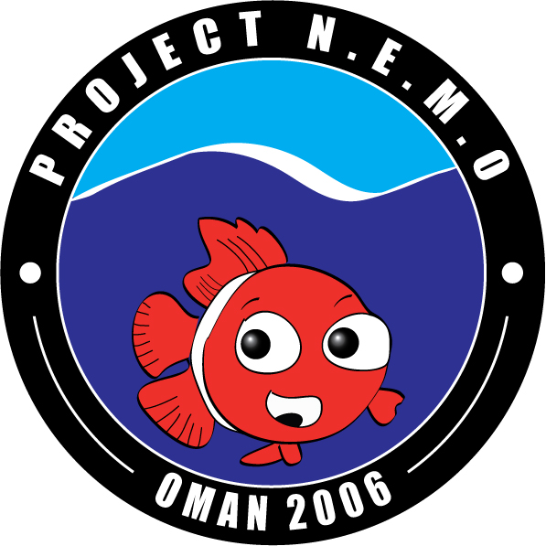
Project NEMO:
An expedition report for the Davies Trust
Contents

- Introduction
- Team Members
- The Science
- Planning the Project
- The Success of the Expedition
- The Results of the Science
- Finances
- Appendix A: Ethics

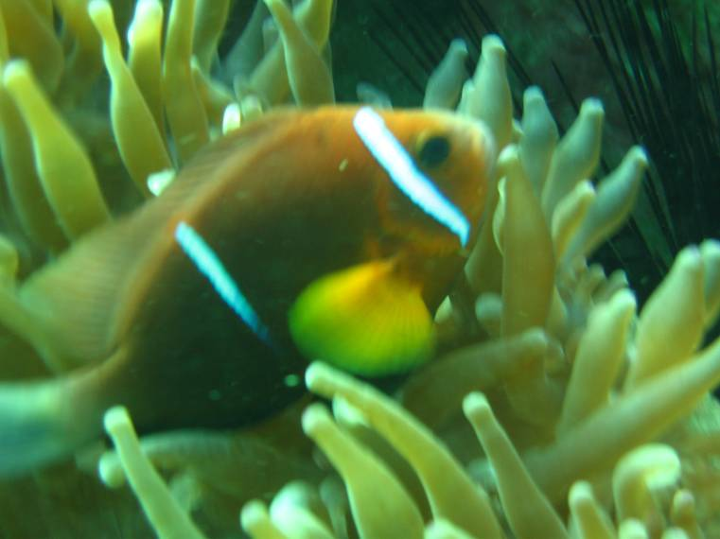
1. Introduction

Project NEMO was an expedition to study the biology of the charismatic Omani clownfish with the hope that our research could guide future management of reef fisheries around the world. Our aim was to establish how juvenile fish choose where to settle, thereby determining how fish stocks can best be protected.

The initial idea for Project NEMO came from Dr Stephen Simpson whilst surveying reefs in Oman in May 2005. Diving near Salalah he saw his first Omani Clownfish (Amphiprion omanensis), which, he learned, is an endemic species to the coast of Oman and which he realised could be used to understand how reef fish select the reefs on which they live. To do this, we needed to collect small tissue samples from as many Omani clownfish as possible along different areas of the Omani coastline. From these tissue samples we can extract DNA on which to carry out molecular analysis. By comparing sections of the DNA we can determine how related individuals are to each other, thereby working out whether individuals were returning to habitats in which they were born, selecting new ones of specific types, or merely being brought to them through oceanic currents.
For more in-depth information see http://www.biology.ed.ac.uk/projects/projectnemo/index.htm

Project NEMO was a fantastic success! Our training began in Britain where we managed to ensure that all members of the team were trained up to the level of BSAC Sports Diver in preparation for the tasks ahead. Months of planning and fund-raising meant that when we arrived in the capital city of Muscat we had extremely welcoming representatives from the Sultan Qaboos University who provided us with vital information, equipment and immense hospitality for which we were extremely grateful.

In a convoy of 6 Landcruisers, we travelled down to the south of the country, from where we worked our way north along the eastern coast of Oman. We camped and dived in many locations on route, attempting to take samples from as many clownfish in as many locations as possible. Most of the sampling was done in the southern regions and from around the island of Masirah. Each bay seemed either to have large populations of clownfish, or none at all. Sampling itself was normally a relatively simple matter of waiting for the fish to retreat into their anemone, enclosing them in hand nets and removing a tiny sample from a pelvic fin before releasing the fish and guiding them back to their anemone. We spent more than four weeks diving for clownfish, though had to forego diving on a number of occasions due to the unseasonably poor weather that sometimes made conditions unsuitable. However, we were still extremely successful, collecting more than 400 samples, which were stored in labelled, alcohol-filled vials and returned to the UK.

Dr. Simpson is currently extracting DNA from the samples and will soon be able to inform us of the results which we will then publish. For further and continued information, please see http://www.biology.ed.ac.uk/projects/projectnemo/index.htm which also includes a more light-hearted report of our work.

Expedition Dates

The main expedition took place from 16 December 2006 until the 7 January 2007. This enabled undergraduate students to fully participate within their Christmas holiday break, and took advantage of the Omani winter, when the sea should have been calm, water visibility good, and the conditions amenable for camping and working outdoors.

In addition to this time, Steve Simpson and two assistants arrived at the start of December to organise much of the logistics. The postgraduate expedition members arrived on 15th December and spent two days organising camping gear and food ahead of the undergraduate arrivals. Following the departure of the undergraduates on January 7th, the postgraduates remained in the country for a week after the expedition, and Steve Simpson and two assistants remained until the end of January to complete the legal documentation for exporting the samples and for some additional survey work.

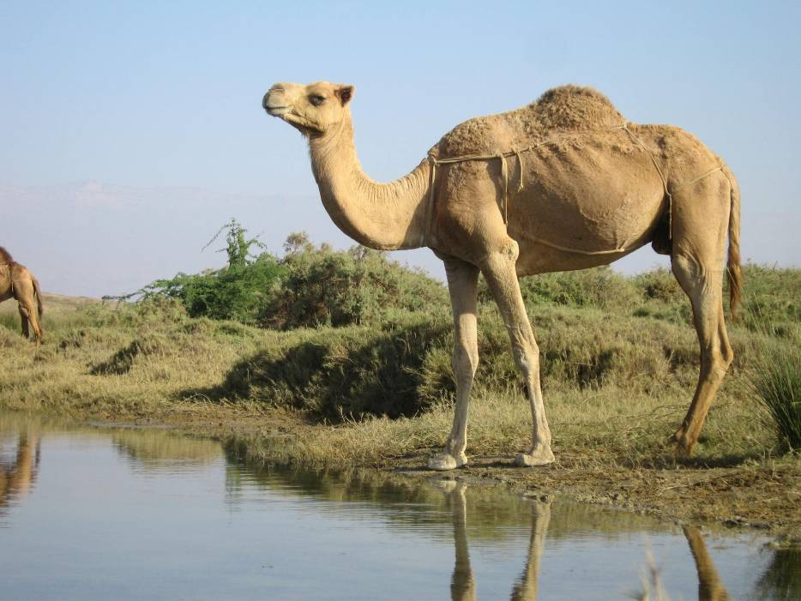
2. Team Members

Expedition Leader Stephen Simpson
Head of Logistics Mark Priest
Science Advisor Elisabeth Rochel
Head of Communications Caroline Simpson
Team Leaders Tabi Innocent
Tom Reed
Matt Robinson
Juan Carlos Ruiz Guajardo
Ed Sykes
Assistant Team Leaders Dan Bayley
Emma Burnett
Ruth Elphinstone
Mike Parker
Ian Stewart
Dive Officer Steve Czyprynski
Navigation and Mapping Fraser Niven
Team Divers Rachel Coleville
Catriona Ferguson
Hugo Harrison
Aidan Hulbert
Adam Kiploks
Clare Nisbet
Vicky Robinson
Harriet Salomonsen

3. The Science
The clownfish Amphiprion omanensis is endemic to the Omani coastline excluding the Persian Gulf, and so unlike most coral reef fishes, its entire global range was easily studied. There were two separate regions where A. omanensis was found (Dhofor and Masirah Island), and we aimed to determine how much exchange of pelagic larvae between regions occurs and how many recruits return to their parents’ reef or other neighbouring reefs within their natal region.

In recent years, many research groups have stressed the importance of conserving coral reefs as they are now becoming severely threatened by destruction and species loss. Human activities such as over-fishing, live fish trade and pollution (sewage, nutrient running off urban and agricultural developments) are largely responsible for the loss of coral reef biodiversity. In addition, climate change and the forthcoming rise in global temperatures are expected to have a significant impact on coral reef diversity. There have been a limited number of studies based on the understanding of the biogeography and phylogeography of coral reef fish. This study is the first of its kind to analyse the larval dispersal, migration and reproduction of coral reef fish populations across their species range. If we are to develop effective conservation strategies to preserve the diversity of coral reefs, we need to increase our knowledge with respect to population structure.
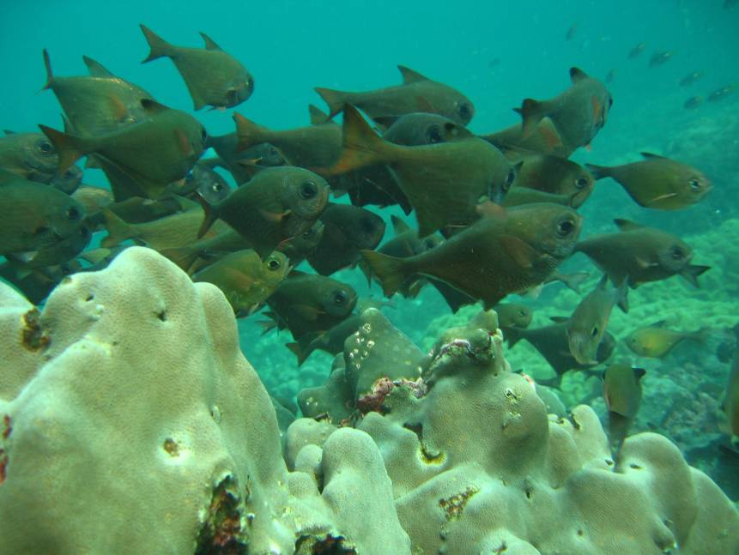

The isolated populations of clown fish found on the southern coast of Oman provided the perfect opportunity to study the structure of marine populations on a large scale. Because of the pelagic nature of clown fish larvae we would expect that DNA samples taken from one geographic focal point could predict the entire species gene pool. To test this hypothesis we collected 350+ samples from across the entire range to measure the diversity of individual geographical foci and their relatedness. Population genetic studies have become increasingly popular over recent years in tracking spatial distribution of fish. Direct screenings of DNA sequences now provide the means to estimate levels of genetic variation with random samples of neutral markers. Although some limitations exist in the use of statistical tools, it will provide us with crucial evidence on the behaviour of coral reef fish populations. The use of population genetics allows the investigation of how gene flow may occur between geographically isolated populations. Understanding this process is essential for designing management plans and marine reserves for conservation and fisheries and will provide a working model of the behavioural patterns of pelagic fish population.

Because this was a large-scale study that involves the collection of many samples, it could only be achieved by the active involvement of many people and their contribution was the only way such an experiment can be realised. In addition, the students involved gained insight into coral reef diversity and the importance of conserving the species that can be found in coastal environments.
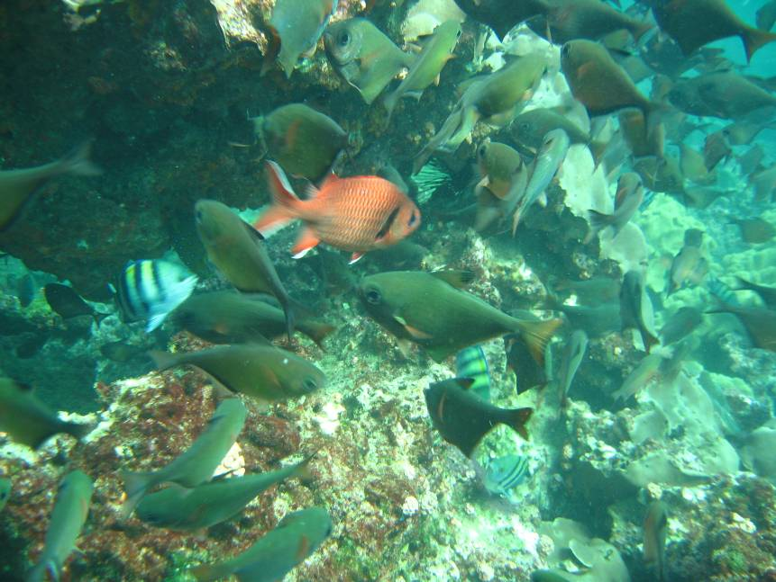
The Science: A History

Dr. Stephen Simpson from the University of Edinburgh formed the idea of collecting DNA samples from reef fish over a large area. With these, he could test if there were clusters of related individuals returning to their reefs of origin, or whether fish were dispersing to new stretches of reef. This work required a model species for which as many individuals as possible could be sampled to make sure that we collected DNA from adult fish that were breeding and from new recruits that had just settled. The Omani clownfish (Amphiprion omanensis) was a perfect candidate, being found only in shallow waters along a 2000-km stretch of coastline in the Gulf of Oman in the Middle East.

Dr Simpson had long been considering using genetic approaches to study population connectivity in coral reef fishes and wondering how one could study exactly how fish populations were divided in order to help scientists and governments develop more efficient Marine Protected Areas (MPAs). Coral reef fish are threatened throughout the world from overfishing, habitat degradation and climate change. The MPAs that have been established so far to correct this problem are based on geographical or human-imposed boundaries, but if we knew more about the population structure of the fish, we could incorporate this into MPA management. This would improve MPA efficiency and help avoid over exploitation of fish populations around the world.

It became clear to Dr Simpson that the Omani Clownfish was an ideal subject for such a study. Because it lives only on the coast of Oman, from Salalah in the south to Masirah Island in the north, it would be possible to study A. omanensis throughout its entire species range to determine the level of mixing between different geographic locations. Since the Omani clownfish lives only in shallow coral reef habitat, it meant that very few populations were inaccessible to the team of SCUBA divers.

In conjunction with Dr Serge Planes, a fish geneticist expert at the University of Perpignan, a plan was made to study A. omanensis by catching fish using aquarium nets and take small tissue samples, which could later be analysed under laboratory conditions. Because A. omanensis lives in union with a host sea anemone to which they retreat when approached, the fish can be collected easily and clipped without being harmed. DNA analysis will show whether fish in different areas are part of the same population, and help define specific boundaries between populations along the coast.

And so the idea for Project NEMO was born.

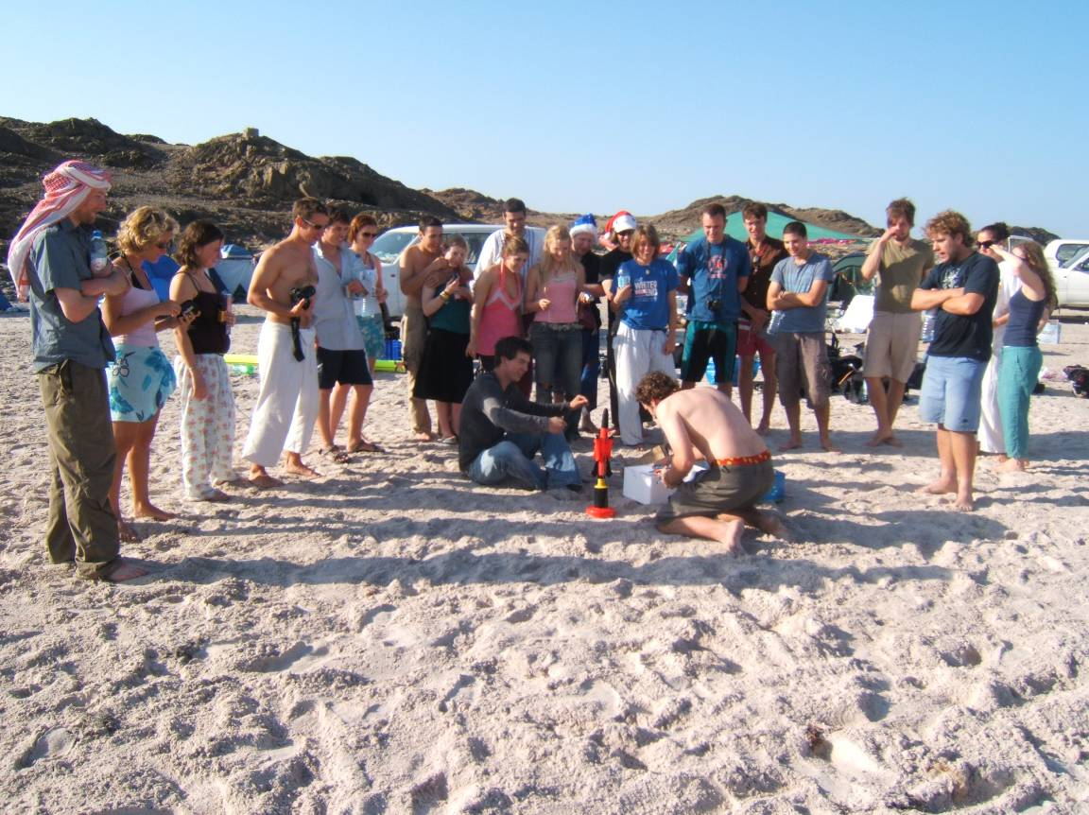
Scientific Methodology

Fin clips were taken from specimens collected from sites strategically located along the entire Southern Oman coastline. Specimens were collected using hand nets and SCUBA. We tried to collect samples from both some mature adults, but also some juveniles where they were found. Surveys of habitat were also made, as well as photos and video recording, and colony characteristics and other observations were recorded.

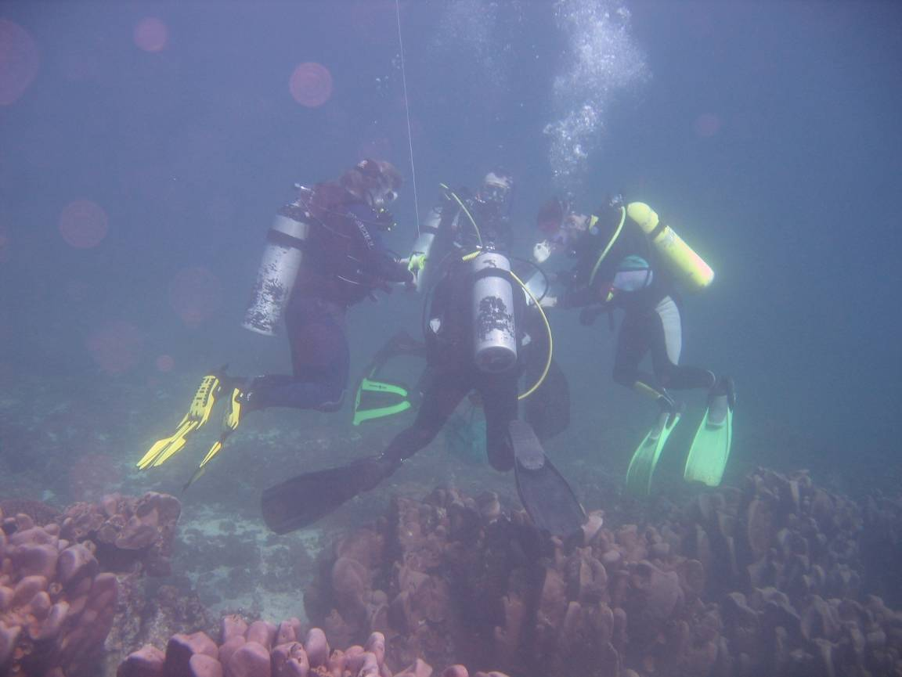
(This photo illustrates divers learning how to collect fin-clips)

We tried to sample from at least 30 individuals from each population during the expedition. Sites were selected to include populations that were relatively near (e.g. neighbouring bays), as well as further apart (e.g. from different regions). The methods for collection were tried and tested following work on previous trips: fish caught in hand nets, held firmly while a clip of the pelvic fin is removed, and then released. This method causes minimal stress and the fish were returned to their host anemone and behaved normally upon release. Fin clips were place in separate vials kept in a wetsuit sleeve, and were labelled and preserved in alcohol at the end of the dive.

At the time and location of each collection, sound recordings, video and photographic records and habitat and fish community data were also collected.

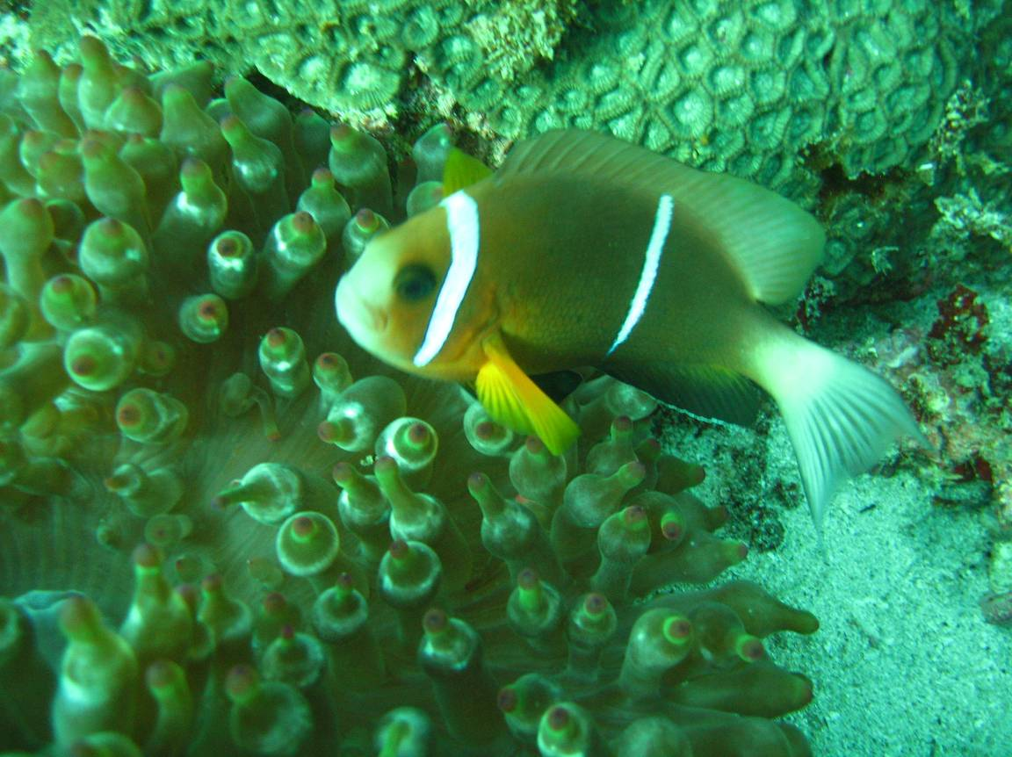

An Extra Project on zooxanthellae

As part of this collaborative project, a subsidiary project was conducted, in which we took samples from the clownfish’s anemone hosts (Entacmaea quadricolor and Heteractis crispa) for genetic analysis. The genetic analysis will be conducted on both the anemone and the zoozanthellae contained within. The anemones are host to intracellular dinoflagellate symbionts called zooxanthellae (Symbiodinium spp.) Investigations of coral zooxanthellae imply the existence of several distinct genetic clades (circa 8) within 9 described species. Clades differ in photosynthetic capacities, light tolerance and production of photoprotective amino acid compounds. Recent studies suggest that some zooxanthellae can be rejected and new strains acquired when corals are exposed to changing environmental conditions. The expulsion of zoozanthellae from their host due to increased sea temperature, salinity or sedimentation may depend upon fitness or environmental conditions.
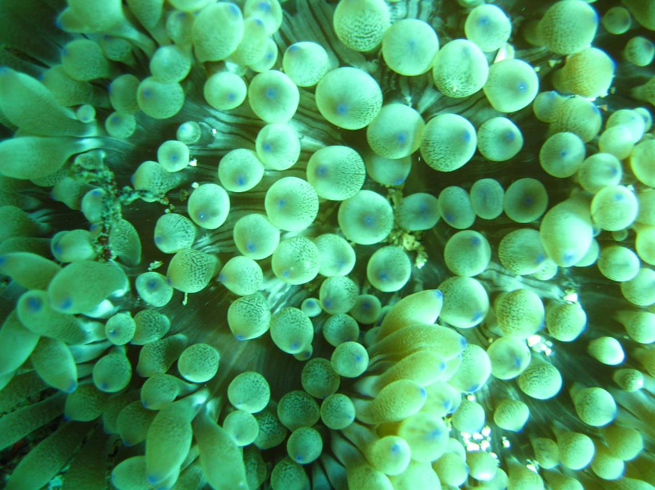
Anemones along the Oman coast are exposed to one of the most unique temperature and nutrient environments of any coral-growing area in the world. Summer upwelling due to monsoon winds reduces surface temperatures, increasing concentrations of dissolved nutrients, elevating plankton and turbidity levels. This exceptional suite of environmental conditions limits the development of corals and shapes the distinctive shallow-water community of the region. These conditions provide a unique opportunity to explore zooxanthellae-cnidarian symbiosis in extremely variable conditions. Our sampling technique also allows the genetic variation in the anemones to be examined along the Omani coastline. As we expect the distribution of anemone to reflect the direction of the prevailing ocean current, they will provide an ideal method of comparison to compare the distribution of the clownfish populations.
4. Planning the Project

Dr. Simpson recruited volunteers to join the expedition and together the group managed to train its members to the level of BSAC Sports Diver and raise over £26,000. In mid-December 2006, the 24 participants arrived in Muscat (Oman’s capital), and once outfitted with all the necessary equipment (a convoy of 4x4 cars completely self-sufficient, carrying their own equipment, compressors, diving gear, camping gear and food) the group headed south. Over the next three weeks, they worked from the southern city of Salalah northwards to Masirah Island. Each day they dived the local area collecting DNA samples from the fish, and each night they set up camp on a suitable beach.

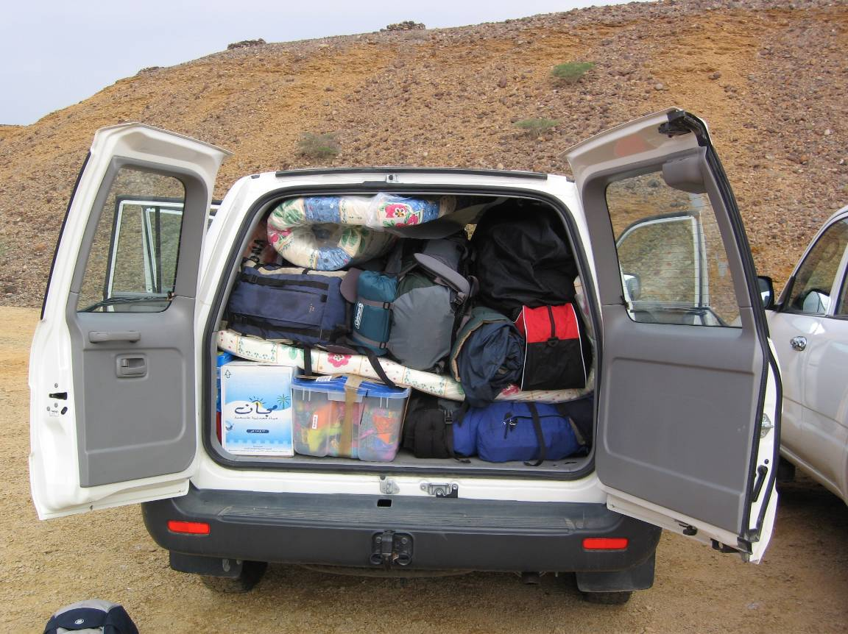

Equipment

Six LWB (long wheel base) 4WD (4 wheel drive) vehicles were rented in Muscat from Global Car Hire, and equipped with food, first aid equipment, mobile phones, VHF radio, satellite phones, walkie-talkies, camping equipment, diving equipment including compressors and maintenance tools & materials, maps & GPS equipment. The driving in Oman was safe, with good tarmac or graded roads, and smaller tracks well-used by local fishermen leading to every bay.

Oman was generally dry and warm during December and January while we were there. As a result this made our camping relatively easy with no need for tents (unless desired) or thick sleeping bags. We generally used 2 season sleeping bags. Mosquito nets were not essential.

For toilet arrangements there were no facilities, but latrines were dug using spades. Depending on available cover, an umbrella was used for privacy.

Daily water requirements were 10 litres per person for those going far off the major roads. The truck carried this in large jerry cans and water bottles. Water was also required for cooking and the rinsing of dive gear.

Good road maps and satellite images were essential for route planning, to find out how often we were near to towns and where the fuel stations were. We carried enough food for 4 consecutive days, consisting mainly of dry goods. We were often in or near towns and villages where we stocked up on food, and where possible, ate in the many local restaurants. Open fires were used to cook all food. We also occasionally carried cool boxes topped up with ice from the fishing factories.

5. The Success of the Expedition

Eighteen months later, after numerous grant applications, fundraising events and dive training weekends, the team of 24 British scientists, students and specialists travelled to Oman to link up with the Sultan Qaboos University in Muscat and begin the project,

During the expedition, the team travelled the length of the Omani coast in a convey of seven four-wheel drive vehicles with one boat, two compressors, and diving, camping and scientific equipment for all team members. In total, the cars covered nearly 50,000 kilometres, and between them, the team spent over 16 days underwater.

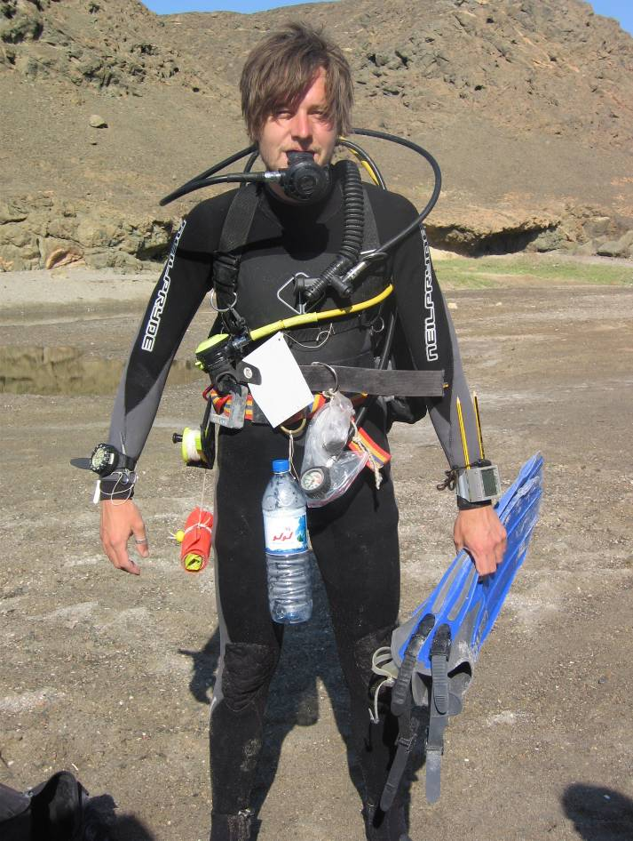
(Matt Robinson modelling the dive kit required for collecting samples)

Starting just east of Salalah, the team camped on remote beaches for several days at a time, and worked from these base camps to conduct surveys in all the neighbouring bays. Each morning, dive teams set off to designated areas of coastline and worked all day to catch and take fin clips from each clownfish they could find. Every evening, these samples were labelled and stored in alcohol to preserve them for the journey back to Europe. Because the survey involved taking a small clip from the fin, it was easy for dive teams to see whether a particular fish had already been sampled, and because the clip was so small the fish were able to swim away unharmed.

The logistical challenges of Project NEMO were huge. Every day, dive tanks had to be refilled, dive teams and dive sites decided upon, food bought and prepared for 24 hungry workers, science kits made up, samples sorted, stored and recorded, routes planned, and camp put up and taken down again when we moved sites. Whenever a camp was established for more than a couple of nights, a projector and screen was set up for lectures on subjects ranging from the behaviour of coral reef fish to Omani corals. An expedition documentary and photo journal was also a constant and time-consuming project for many team members.
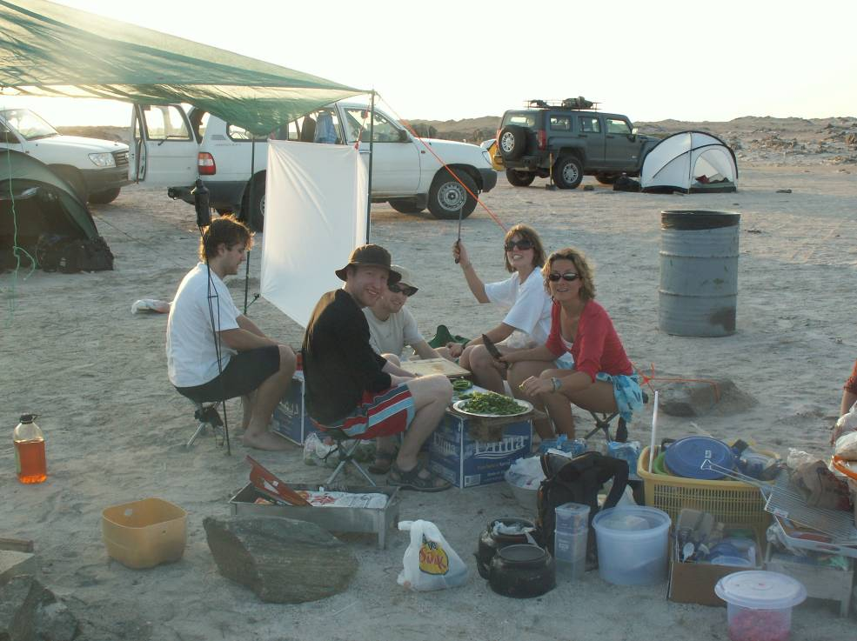

The weather was an unexpected challenge at times, with winds up to gale force six, sandstorms and flooding hampering the expedition’s progress. With many camps situated in remote desert, food rations were limited and the local staples of rice, flatbreads and beans quickly became our dietary mainstays - with the occasional gift of fish from local fishermen thrown in.

Apart from one trip back to Muscat to treat two dodgy teeth and an ear infection, the group stayed generally healthy and fit. The SCUBA diving was all strictly monitored, with a minimum BSAC Sports Diver qualification necessary for participation in the project, as well as 50 bar minimum of air left in reserve after each dive, no tissue-nitrogen loading beyond code D, and a three hour surface interval between every dive. Christmas and New Years day were both team rest days, and no-one spent more than five consecutive days diving.

The challenges of travelling and working in Oman were made easier by support for the project by Ali Al-Kiyumi, the Director General of Nature Conservation at the Ministry of Regional Municipalities, Environment and Water Resources, and Ali Salem Bait Said, Director of Nature Conservation and Wildlife, Governate of Dhofor. Ahead of the survey work, Dr Simpson (as Expedition Leader), Mark Priest (Head of Logistics) and Caroline Simpson (Head of Communications) met with ministry officials on several occasions in Muscat and Salalah to obtain official diving and scientific work permits. As a result, each car contained a simple description of the project in both English and Arabic, which many Omani fishermen along the way read with interest to learn about what we were doing. Local customs, such as not drinking alcohol and dressing modestly at all times, were also strictly observed by all members of the team.

Despite spending Christmas and New Year in a Muslim country, the Western celebrations were marked in inventive and unusual ways. The camp and all the cars were decorated with tinsel and sarongs, special meals were cooked, songs invented - including ‘The Twelve Days of NEMO Christmas’ - and a giant game of human Cluedo organised.
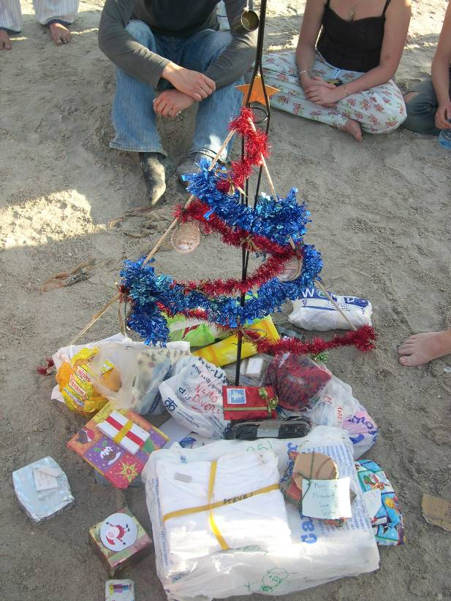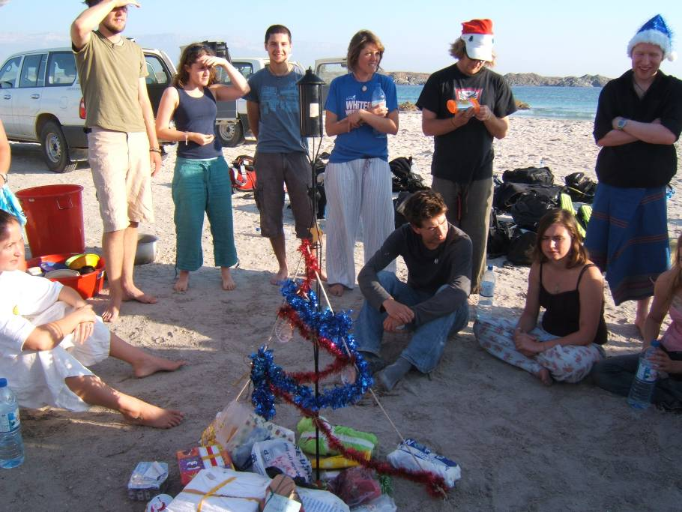
6.The Results of the Science
Now that the group are home, we are excited to analyse the samples and determine the results of the expedition. We may find that the Omani clownfish lives in very small populations, and does not travel between bays during their larval life away from the reef, which would suggest that small, contained MPAs would be best. Alternatively, we could find that fish from Masirah mix regularly with fish from Salalah and at all points in between, which would mean that one large MPA across a coastline would suit the biology of coral reef fish. Whatever the genetic study presents, we can be sure that the work done by Project NEMO will help MPA management teams protect our seas, and our fish, for future generations.

Marine conservation is vital for the survival of the oceans, and Marine Protected Areas are being heralded as an important solution. However, efforts to create marine reserves are hampered by a lack of understanding about the fish stocks that we are trying to protect. Managers don’t know whether it is best to create single large reserves or multiple small ones. The reason is that most reef fish leave the reef when young in order to escape predation, only returning once large enough to settle, and we don’t know whether they return to the sites where they are born, choose new reefs with better habitats, or are simply swept away in strong currents. If the fish are not returning to the reefs where they were born, then protecting isolated sites will never work.

The group completed over 200 dives (without incident) and managed to collect over 350 DNA samples. This was a great success and the lab analysis of the samples is now underway at the Université de Perpignan (Steve Simpson & Elisabeth Rochel). The analysis may show that Omani clownfish live in very small populations, and do not travel between bays during their larval life away from the reef, which would suggest that small, contained protected sites would be best. Alternatively, we may find that fish from the north mix regularly with fish from the south and at all points in between, which would mean that one large protection zone within the species range would suit the biology of this, and similar, coral reef fish. Whatever the genetic study presents, we can be sure that the work done by Project NEMO will help management teams protect our seas, and our fish, for future generations.

7. Finances
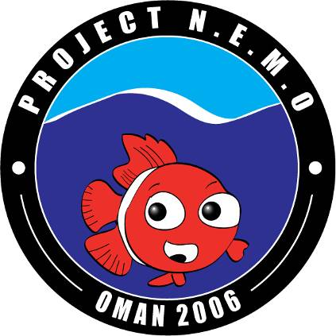

Project Nemo – Breakdown of Expenditure

Description | Cost (£) | Cost (OR)
24 Flights from Europe | 9,861.12 | 7,043.657
Insurance | 1,370.00 | 978.571
Diving Equipment Hire | 6,945.89 | 4,961.350
Vehicle Hire (6 4WDs) | 6,845.20 | 4,889.429
Food & Camping Kit | 1,232.66 | 880.469
Other transport costs | 707.00 | 505.000
Fuel costs ** | 274.12 | 195.800
SQU Boat costs | 228.97 | 163.55
Communications | 25.90 | 18.500
GPS and Radios | 368.80 | 263.429
Underwater Video Camera | 1,960.02 | 1400.014
Science Kits | 432.83 | 309.164
Data Projector | 489.86 | 349.900
Nature Documentary DVDs | 221.49 | 158.207
ID guides & Manuals | 99.47 | 71.050
Miscellaneous | 688.80 | 492.000
Total Costs | 31,752.13 | 22,680.090

** Fuel costs do not include 5000 litres of petrol kindly supplied by Shell Oman

To date we have raised £19,210 (OR 13,721.430) from grants and sponsorship, and received £12,542.13 (OR 8958.665) in personal contributions from participants.
Appendix A: Ethics

When planning an expedition it is important to consider human ethics in terms of the social situation and codes of conduct in the country you plan to visit. By considering human ethics you can avoid harming or offending people in the country you intend to visit. We will ensure that all expedition members are aware of the economic and cultural background of Oman and Omani nationals. In Oman, there are certain codes of conduct that should be followed. Virtually all Omani nationals are Muslim and strictly follow the rules of the Koran. This involves praying 5 times each day (dawn, midday, mid afternoon, sunset and nightfall). The typical prayer time lasts about 10-15 minutes. As we may be working with Omani students it is important to take these prayer times into account when planning daily schedules. In terms of interacting in a positive way with Omani people it is important to behave discretely and respectfully in public places. Public displays of affection are not seen and clothing is conservative. Women should only wear swimwear when at the beach or pool and should have shoulders, knees and chests covered at all other times. Men should avoid wearing shorts or going bare-chested in public, except at the pool or beach.

Other codes of conduct include never showing the soles of your feet, Omani people regard this as rude behaviour, men must not touch or shake hands with Omani women unless they initiate it and you should only shake hands and eat with your right hand. You should never serve pork or alcohol to a Muslim or ask them to serve it to you. Another social consideration to be taken into account is taking photographs of local people. When doing so the permission of the people in the photo should be sought and it should be realised that photographs are not always appropriate. It is also important to take into account the economic situation of the country you intend to visit. During our expedition we will be aware of differences in economics and will attempt to spend money locally where possible.

