JAMES RENNIE BEQUEST

REPORT ON EXPEDITION/PROJECT/CONFERENCE

Expedition/Project Title: Project Mbegu: Conserving Plant Biodiversity in the Coastal Forests of Eastern Africa - Integrating ex situ and in situ Conservation in the Shimba Hills, Kwale District, Kenya.

Travel Dates: 15th June to 7th August 2006

Location: Shimba Hills National Reserve, Kwale District, Kenya

Group Member(s): Hannes Dempewolf, Sally Hinds, Damian Bienkowski, Lucy Inns, Thomas Waibel (all of U of E), Chan Moses (UBC, Canada), Robert Kiru, Joshua Muasya, Mathias Muindi (NMK, Kenya),

Aims: The aim of Project Mbegu was to complement current in situ and ex situ plant conservation efforts in the Shimba Hills, Kwale district, Kenya, one of the last remaining fragments of the coastal forest of East Africa, a world biodiversity hotspot. Specific aims were: i) to improve herbarium records of under-collected and potentially new plant species through targeted specimen collection, ii) to increase the number of native species stored as germplasm in ex situ conservation in the country of origin, iii) to assess the conservation status of selected threatened endemics within the reserve, iv) to develop the skills, knowledge and cultural awareness of participants through knowledge exchange and technology transfer, v)to disseminate findings and promote awareness of the importance of the conservation of the flora of the Shimba Hills.

OUTCOMES (not less than 300 words):-

Conservation Assessments
Current in situ conservation measures were supported by updating the conservation status for eleven rare and endemic plant taxa.

Plant Collections
In situ measures were also supported by the collection of specimens of under collected and potentially new plant species, as well as species new to the local and national checklists. 376 plant specimens with field notes were collected and recorded in a BRAHMS database, a botanical database system widely used by botanical gardens around the world. Once identified, the samples were mounted with field notes, and added to the collections at the East African Herbarium in Nairobi.

Seed Collections
31 new seed accessions for previously unbanked native plant species were added to the collection at the National Gene Bank of Kenya for ex situ conservation. For each accession sufficient seed was collected in order to make germplasm available for safeguarding outside the country of origin in the Millennium Seed Bank, Kew.

Databases
In addition to the BRAHMS database, a database of collected plants including field notes, observations on distribution, habitat, conservation status etc, medicinal uses and colour photographs was compiled and made available to the Kenya Wildlife Service (KWS). Spatial data was made available to the National Museums Kenya in order to be incorporated into their spatial dataset for the region. This will allow future researchers and plant collectors of the area to direct their efforts more accurately. GIS data collected during the project was also made available to the scientific officer at KWS in the form of a database which will be maintained in the future by the KWS scientific officer.

Technology Transfer
Capacity building of local staff at the Shimba Hills KWS station was also carried out. In particular the Kenya Wildlife Service Scientific officer in the Shimba Hills was trained in the use of basic GIS software tools as well as GPS units. With this newly acquired knowledge he will now be able to guide researchers to sites of taxonomic interest within the reserve. He will also be able to readily add future accessions to the database, thereby increasing the utility of this growing data resource for future researchers in the Shimba Hills from diverse disciplines. In addition practical, intellectual and cultural exchanges between expedition members from Kenya and the U.K. were of great benefit to all involved and fundamental to the aims of the project

Dissemination
The importance of plant conservation was communicated through a series of presentations to primary schools in the Shimba Hills local area and to visiting secondary schools at the National Museums of Kenya in Nairobi. The uniqueness of the flora of the Shimba Hills and the consequent importance of its conservation was promoted through the production of a brochure entitled ‘Plants of the Shimba Hills’ (Figure 1). This colour brochure, which was aimed at the general public, was published by Project Mbegu in Nairobi and distributed free of charge within Kenya through the Kenya Wildlife Service.

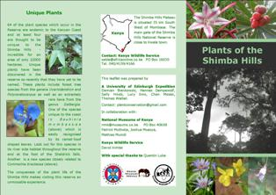
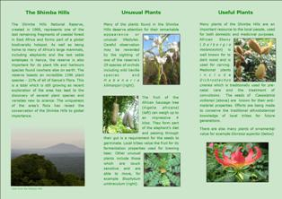

Fig 1. The colour triptych brochure produced by Project Mbegu in Nairobi. i) front and ii) back

For a full length expedition report or electronic copy of the brochure produced please contact Sally Hinds: s.e.hinds@gmail.com or Hannes Dempewolf: hdempewolf@gmx.de

