JAMES RENNIE BEQUEST

REPORT ON EXPEDITION/PROJECT/CONFERENCE

Expedition/Project/Conference Title: Molecular Approaches to Malaria 2008

Travel Dates: 4th February -7th February 08

Location: Lorne, Victoria, Australia

Group Member(s): Ruth Corrigan

Aims:
- To present a poster “Rosetting and the Immune Response to Malaria Parasites”.
- To discuss my PhD work with leaders in the field, in particular Professor Eleanor Riley and Dr. Louis Schofield who both specialise in closely related areas.

OUTCOME (not less than 300 words):-

The Molecular Approaches to Malaria (MAM) conferences occur only once every four years, and are regarded as one of the most informative, useful and informal malaria conferences currently available. With this in mind, (together with its fabulous beachside location), I feel very lucky that this third MAM conference fell during the third year of my PhD, and very grateful to the James Rennie Bequest for awarding money to facilitate my attendance.

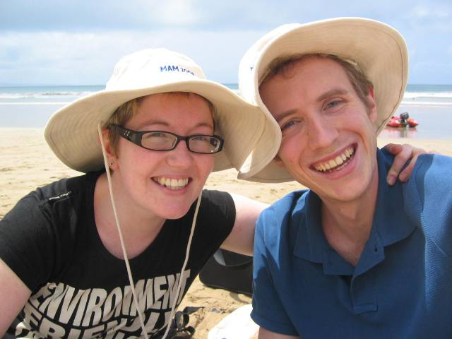
MAM 2008 was attended by 400 delegates and consisted of a ‘three-day, sixty-talk, two-hundred and-thirty-poster’ action-packed resume of the latest from the field of malaria research. Days were filled from 8:30am-6:30pm with talks from most of the frontrunners working on malaria, and resumed after dinner for animated and involved poster sessions which continued until well past midnight. However despite such an extensive scientific program, the organisers made sure that the conference remained informal, indeed the pre-conference website advised “Formal clothing such as a suit and tie are not necessary. (Don’t forget your swimming costume!)”, thus making it very easy to mingle with the best in the field rather inconspicuously!
Myself with fellow Edinburgh student Antoine sporting conference hats!

The conference was hosted by the Mantra Erskine Beach Resort in Lorne, complete with ‘Aussie’ Welcome Barbeque, resident cockatoos, and even the odd kookaburra. All meals were served in house, and provided a further opportunity, as well as coffee breaks, to grab the attention of important people. We even found half an hour to investigate the beach, and to leave behind a record of the conference for unsuspecting holiday makers!

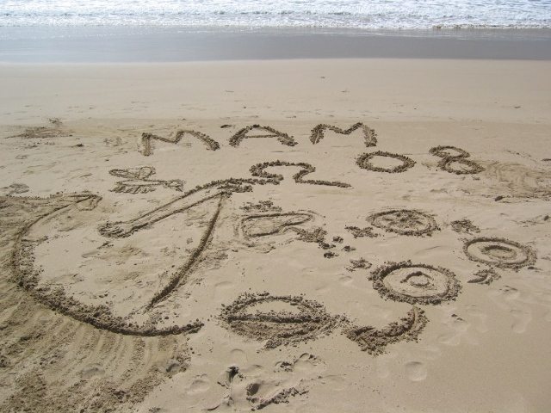
I attended the conference with two main aims in mind; to present my poster summarising my PhD work so far entitled “Rosetting and the Immune Response to Malaria Parasites” and use it as a springboard to encourage further discussion, and secondly to track down two scientists in particular currently pioneering work in my field.

I was very pleased with the design of my poster and happy to find that it was located opposite the beer counter, thus ensuring that I had a steady stream of customers all night! My poster was divided into two sections, presenting two aspects of my work to date. Firstly, phagocytosis of malaria parasites by macrophages and secondly, activation of lymphocytes by malaria parasites as measured by IFNγ production. The data related to phagocytosis proved to be the most popular, and several people approached me to discuss it. These included members of Stephen Rogerson’s group who are looking at the effect of HIV infection on phagocytosis of malaria parasites, and people from Odile Puijalon’s group who are looking at clearance of malaria parasites by macrophages in the spleen. Both groups were keen to talk about the techniques I used and how my data may fit in with their own, and the ‘bigger picture’. The second part of my poster, presenting the data relating to activation of lymphocytes by malaria parasites gained the attention of Hans Peter Beck, who works with Mats Wahlgren. This proved a particularly interesting discussion as the Walhgren group also work on rosetting, but have some rather different ideas about the mechanisms involved.
The malaria life cycle on the beach at Lorne: a gift for unsuspecting tourists!

I was very pleased as Eleanor Riley (number one on my scientist hit-list) also came to look at my poster. I was able to ask her questions about her work, as well as my own. She answered very positively and helpfully, and gave me one or two useful pointers to clarify my observations.

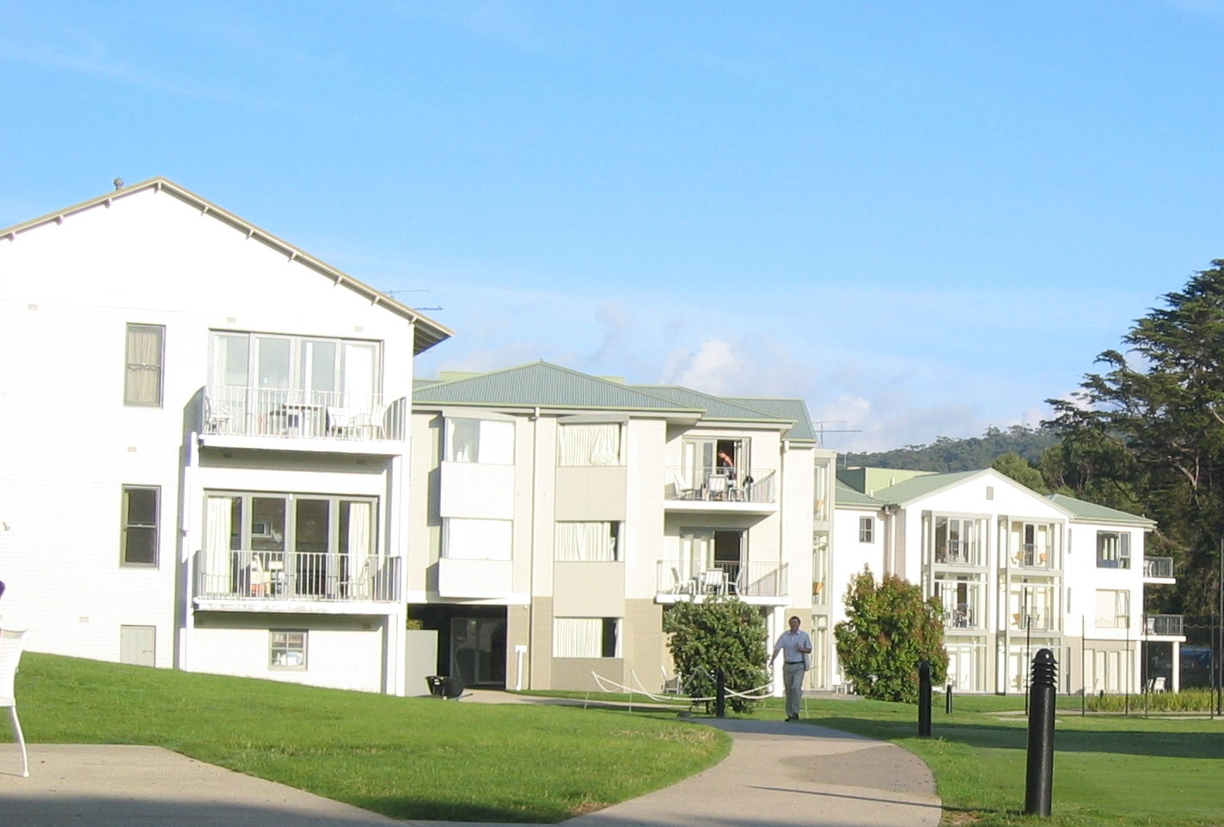
Second on my hit-list, Louis Schofield, provided in my opinion, the most interesting talk of the conference. He summarised his findings from a longitudinal reinfection study from children in Papua New Guinea, looking at how the response of their lymphocytes by malaria parasites correlated with subsequent disease parasitaemia and symptoms. Interestingly, he found that high IFNγ was associated with reduced disease severity, but was not a predictor of reduced parasite burden. He also has recently published work suggesting that the most studied parasite antigen (PfEMP-1) may actually inhibit immune responses. This is very relevant to my work as the parasites I study, it is thought, differ only in the type of PfEMP-1 expressed. Therefore any differences in immune responses that I see could be related to this inhibitory property. I asked him how he thought all of these observations could hang together and he provided some encouraging suggestions. However, having returned home and followed up with these ideas, it seems things are rather more complicated!
Conference accommodation at the Mantra Erskine Resort in Lorne.

To summarise, I found the conference incredibly motivating and a wonderful opportunity to discuss the latest work in the field. I was really excited to present my data to an interested and expert audience, and to find that they were encouraging and helpful. Thank you again to the James Rennie Bequest for awarding me money for travel thus making my attendance possible.

