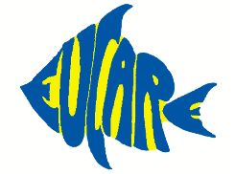
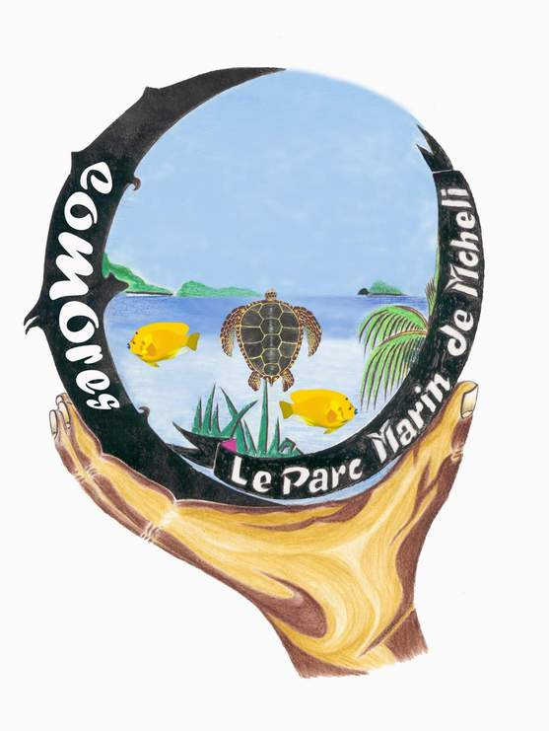


EUCARE Comoros 2002
Edinburgh University Coral Awareness and Research Expeditions

Preliminary Report October 2002

Introduction

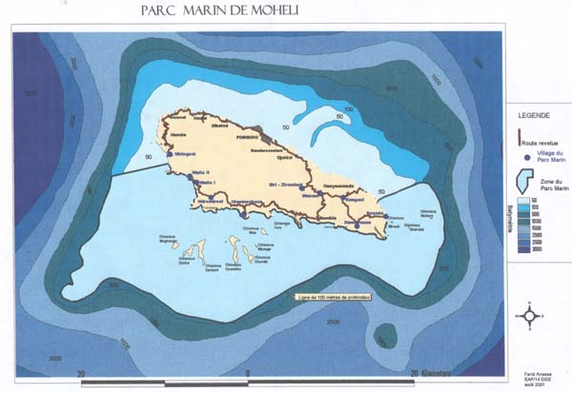
The EUCARE teams original proposal was to map the uncharted reefs of Belo sur Mer in western Madagascar, but due to the current political situation at the time, it would have been impossible for EUCARE to fulfil all objectives laid out before the expedition commenced. The team followed up their contingency plan to the Comoros archipelago. The archipelago comprises of four isolated volcanic islands in the Western Indian Ocean, located to the east of Northern Mozambique and North West of Madagascar. The Marine Park of Moheli (PMM) is situated in the southern extremity of Moheli, the smallest and youngest of the Islands in the Comoros archipelago, (see figure 1). It covers an area of 404 km² along the south and west coasts of the island and extends from the shoreline to a depth of 100m. The PMM was initiated by Projet Conservation de la Biodiversité et du Développement Durable aux Comores (Projet Biodiversitié), that is a World Conservation Union (IUCN) / Comorian Ministry of Production and the Environment project, funded by the Global Environment Facility (GEF) and the United Nations Development Program (UNDP),,.
Figure 1 showing Moheli and the borders of the Marine Park. Kindly donated by Megaptera.

The EUCARE team was based in Nioumachoua and Itsmaia from early July to the end of September 2002 and worked with the Projet Biodiversité and a local NGO, Association d’Intervention pour le Développement et l’Environnement (AIDE). The team carried out extensive surveying around the marine park (figure 2) identifying fish, coral and other invertebrate species as well as other environmental and anthropologic data.

Methods

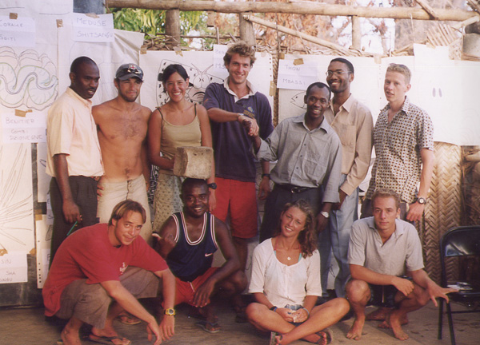
EUCARE sent survey teams of divers to collect baseline data fish, corals and invertebrates,. The EUCARE underwater survey technique was modified to work in a quantitative methodology used by AIDE scientists, through the Commission de l’Océan Indien (COI). The methodologies used were Line Intercept Transects, Live Fish Censuses and the EUCARE Underwater Survey Technique. This allowed the data to be included in any long-term studies that AIDE may carry out in the area. The modification allowed the team to complete its aims and enhanced the sustainability of coral reef health monitoring in the area. EUCARE also noted any oceanographic data and anthropogenic impacts on the reefs. Each survey team was composed of at least one host nation scientist and a diver qualified to at least PADI Dive Master. EUCARE also undertook presentations to the local communities of Nioumachoua and Itsamia. These sessions were given to school children, college (Lycee) students, local fishermen and the members of the associations of these villages (Photo 1). EUCARE held a conference in Moroni entitled “Expédition sur les fonds du Parc Marin de Moheli” for the scientific community and public of the Union of the Comoros.
Photo 1, showing the team after a workshop held for college students at Nioumachoua.

Results

Results show overall coral re-growth from 20 – 50%. The area of greatest coral health and diversity is on the northern and least exposed side of Mea (figure 2).
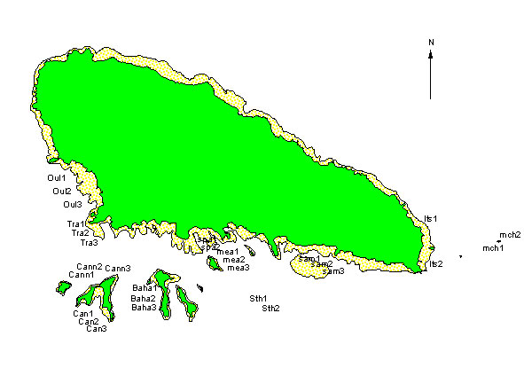
Figure 2. A map showing sites dived during the EUCARE expedition the PMM in 2002. Further information such as habitat areas will be mounted onto this map to give the first map of the marine environment of the PMM.

At this stage the main points raised by the expedition are as follows:

  - A high amount of bleaching was seen in the PMM in 1998 that can be directly attributed to the El Niño phenomenon.
  - Coral coverage is seen ranging from 20 – 50% and healthy coral re-growth has been observed. It cannot be concluded if to what extent this is natural or due to the establishment of the PMM. The greatest coral coverage was seen in sheltered areas and re-growth in exposed areas may be slow.
  - A healthy population of reef-associated fish were seen in all areas, especially those areas of higher coral re-growth and diversity. Of special interest is the Island of Mchaco that lies to the east of Itsamia. This area showed the highest diversity of both reef associated and pelagic fish.
  - Areas of destructive fishing practices were seen. These could not be aged. During the expedition, however, dynamite blasts were reported.
  - High amounts of sedimentation were seen to the north of Itsamia. This meant a very low level of coral coverage seen in this area.
  - The EUCARE team, working with AIDE and Projet Biodiversitié identified in the region of 275 species of fish, that is 75 than previously described, 110 species of invertebrates that are newly described for the region and 20 families of corals.
  - Fish and invertebrate species have been identified that can be used as indicator species for the continuation of monitoring of coral reefs in this area in cooperation with AIDE and Projet Biodiversitié.
  - EUCARE carried out presentations to the communities of Nioumachoua and Itsamia. These talks aimed to be provide information on the marine fauna of the region, the work of EUCARE and the threats that reefs are under as well as providing positive information on ecotourism. These talks identified that the fishermen of the PMM feel that they have not been given sufficient compensation for the restrictions enforced upon them. Further studies into the fishermen of the PMM may identify solutions to these problems.
  - The PMM is suitable for an expansion of ecotourism. As well as suitable and accessible sites for recreational SCUBA diving and snorkelling, an abundance of other marine species of interest to the ecotourist were noted throughout the expedition. These included Humpback Whales, Spinner Dolphins, Manta Rays, Green Turtles and Hawksbill turtles (Photo 2). The main limitation on the expansion of ecotourism in the area is transportation to and around the Island of Moheli.
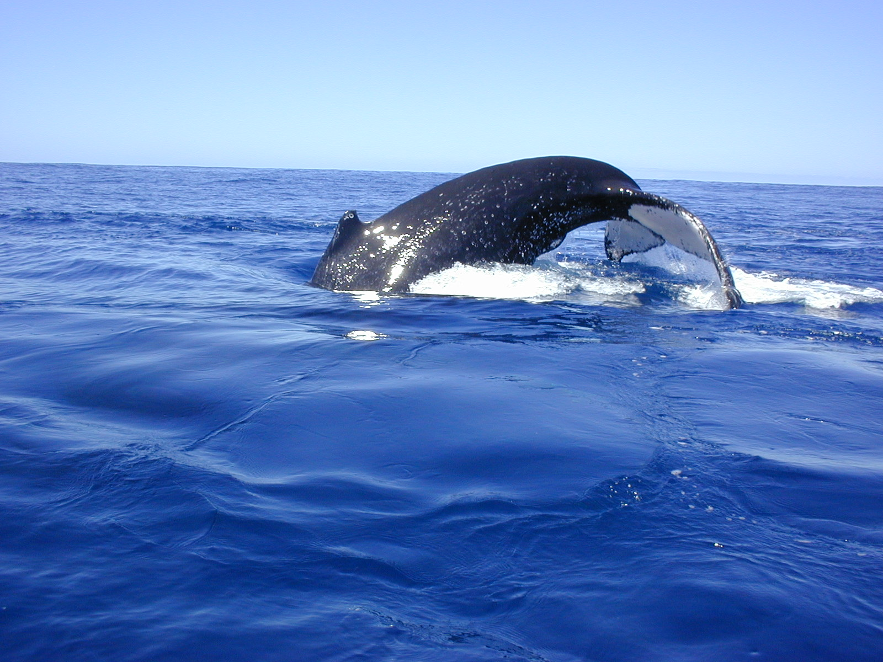
Photo 2. A humpback whale in the PMM. Photo courtesy of Michel Vely and Megaptera.
Safety

In view of the dangerous nature of the work carried out, the EUCARE diving protocol was strictly adhered to at all times, and bottled oxygen was carried on the dive boat and on shore. In addition to the dive boat, 4x4 vehicles with local drivers were kept on standby as close to the dive sites as possible in both phases of the expedition. Contact was maintained between the dive boat, shore guard and local police station at all times and a satellite phone was carried on the boat for immediate access to local light aircraft. On the 26th July a fire occurred at the team base in Nioumachoua, a structure made from concrete with a roof made from palm leaves. No one was injured in the fire and the team remained in tented accommodation and used a local village association room as a team area and the Projet Biodiversité storeroom for storing fuel, motors and equipment. No other accidents or significant medical problems occurred on the expedition.

Conclusion and Recommendations

EUCARE identified a wide diversity of fish, corals and other invertebrates in the area. Coral coverage in the PMM ranged from 20 - 50% and healthy coral re-growth was seen in sheltered areas. Exposed areas showed a lower extent of coral re-growth. Continued monitoring of the corals of the PMM will allow the continuation of the work undertaken by EUCARE and allow analysis of coral health in this area. Further to this studies of coral recruitment may give a further idea into coral re-growth. Sedimentation was seen in the area of Itsamia where there is a river out flow. Studies into sedimentation rate and load in this area, in Oullah and other areas not boarded by river outflows will mean that sedimentation can be evaluated in the PMM. This study may be especially valuable if agricultural practices expand on Moheli. A key of species will be identified, similar to that used by the COI in monitoring areas in the Western Indian Ocean. This will allow the monitoring of coral ecosystems by non-scientific personnel, such as eco-guards and locals of Moheli. EUCARE hopes to identify areas where diving and fishing practices will be restricted, so that there effect on reef health can be monitored in future years. The PMM is suitable for an expansion of ecotourism.

Further work within Moheli could continue the work of EUCARE 2002. This includes monitoring fish, coral and other invertebrates, monitoring coral health, sedimentation studies, coral bleaching studies and coral load. Further work on marine mammals could be done with Megaptera, a group working on Humpback Whales. Studies on marine reptiles could also be monitored on the Islands and at Itsamia.
Acknowledgements

EUCARE would like to thank all of its sponsors, The Royal Geographical Society (with the IBG), the Royal Scottish Geographical Society, The University of Edinburgh, The Davis Trust, Swann travel fund. The British ecological society, James Rennie Bequest, Shell travel bursaries, Barnson Bequest and Weir Fund for Field Studies, William Dickson travelling fund, the Carnegie Trust, the Ede & Ravenscroft Prize and the Rufford Small Grants/Whitley-Lang Trust.

EUCARE would especially like to thank Projet Conservation de la Biodiversité et du Développement Durable aux Comores, the IUCN, the Comoran Ministry of Production and the Environment project, the GEF and the UNDP. In particular EUCARE would like to thank the Director of Projet Biodiversité, Said Mohammed, for his support throughout the expedition, Sue Wells for her support and Fouad Abdou Rabi for his hard work and support on Moheli. EUCARE would also like to thank AIDE and the CNDRS for there support and in particular Said Ahmada and Soifa Ahamed for their help and expertise throughout the project. EUCARE would like to thank Megaptera for the experience received in working with Humpback Whales and Michel Vely for his support throughout the expedition and Kamar Boinali the Conservator of the PMM. EUCARE would also like to acknowledge other help and support received throughout the project that are too numerous to mention in this preliminary report.

Contributors

Robert Conway, Donald Asprey, Robin Boyd, Lucy Jack, Natasha Lippens, Ben O’Connor, Carey Quarrier, Richard Swatman, Said Mohammed, Said Ahmada, Fouad Abdou Rabi, Soifa Ahamed.

Contact

Rob Conway
EUCARE Project Coordinator Comoros 2002
45 Home Park Road
Wimbledon, London, SW19 7HS
United Kingdom
Phone: +44 (0)20 8946 4294, Fax: +44 (0)20 8946 4294
Email: rob@eucarenet.com
Appendices

Itinerary

The preliminary EUCARE team, comprising of 4 team members, arrived in Nairobi for discussions with Sue Wells of the IUCN on the 4th of July. The team arrived in the capital of the Comoros, Moroni, on the 9th July. Flights depart once a week from the Islands to Nairobi or Madagascar. It is possible to get more frequent flights from the French Administered Island of Mayotte. The team stayed in Moroni to organise logistical matters for the less developed Island of Moheli, and to finish administration, such as finalisation of research permits and visas. Meetings were held between EUCARE, AIDE, the CNDRS and Projet Biodivesitié. The preliminary team used fishing vessels and arrived in Moheli on the 16th July to set up camp and secure transport on the island. A boat and driver was hire through the village association of Ouallah 2. A local driver was indispensable as a local guide. A 4x4 was available for team use after discussions between EUCARE and the Projet Biodiversitié and fuel and supplies were transported from the capital Moheli once or twice a week using this vehicle or local transport. Taxi Brousse’s run daily between Nioumachoua and Fombni, and it is possible to order supplies through these routes. A fresh water supply was located next to the EUCARE camp and fuel and motors were stores in the Projet Biodiversitié storeroom. Diving scientific equipment was washed daily and dried on the EUCARE equipment stand constructed in the EUCARE campsite. Equipment was stored in the team room over night. The remaining team members, including AIDE scientists arrived on the 26th July, after reconnaissance of Aquarium diving on Grande Comore. The team remained in Nioumachoua for the majority of the expedition due to its central location and ease of getting to survey sites. The team spent a week in Itsamia on the east coast of Moheli from the 4th September. This provided ease of access to the Island of Mchaco and the surrounding East coast of the island. Itsamia is not as developed as Nioumachoua but has fresh water. All supplies, except for fresh fruit, have to be driven in from Fomboni, and a taxi brousse operates daily to and from the capital. Itsamia is famous for green turtle nesting and further projects may be available in the area studying these turtles. Presentations were carried out over the month of September in Itsamia and Nioumachoua. The team departed Moheli on the 19th September and organised a conference at Projet Biodiversitié in Moroni. The team then departed on the 24th September.

Financial Support

Financial support was adequate for the expedition. Food on the island is inexpensive, however it must be emphasised that it is necessary to plan expedition needs as many products must be ordered from Grande Comore that can take up to a week. Fresh fish was available if the weather permitted fishing. A fridge is located at the Moheli Bungalows that will allow the storage of foods and medicines. A full budget will be available in the final expedition report to be completed early 2003.

References

Abdoulhalik F M. Marine Science Country Profiles, Comores. Intergovernmental oceanographic commission Western Indian Ocean Marine Science Association, UNESCO, WIOMSA. 1998
Fatouma A A, Bicarima A and Ahmada S. Report of the State of the Management of Protected Amrine areas in Comoros. UNEP, 2000.
Kelly RW et al. Comoros, 2002 Country Review. (Available online at http://www.countrywatch.com)
Quod, J.P. and L. Bigot., Coral bleaching in the Indian Ocean islands: Ecological consequences and recovery in Madagascar, Comoros, Mayotte and Reunion. In Souter, D (ed); Obura, D (ed); Linden, O (ed). Coral reef degradation in the Indian Ocean: Status reports and project presentations 2000. pp. Pp108
Bigot L et al. Status of Coral Reefs of the Southern Indian Ocean: The Indian Ocean Commission Node for Comoros, Madagascar, Mauritius, Reunion and Seychelles. Status of the Reefs of the World, 2000.
Souter D, Obrura D, Linden O. Coral Reef Degradation in the Indian Ocean, Status reports and project presentations 2000. CORDIO, ISBN 91-973959-1-9
Myers R (2001). Collins Coral Reef Fish Pocket Guide Collins. ISBN: 0007111118
Vernon J.E.N, (2001) Corals of the World, Vol. 1, 2, 3. ISBN’s: volume 1: 0 642 32236 8, volume 2: 0 642 32237 6, volume 3: 0 642 32238 4.
Richmond MD. A Guide to the Seashores of Eastern Africa (and the Western Indian Ocean Islands). Sida. ISBN: 91-630-4594-X, 1997
Westmacott, S., Teleki, K., Wells, S. and West. J. M. Management of bleached and severely damaged coral reefs. IUCN ISBN: 2-8317-0545-2 2000 (available online at http://www.iucn.org/themes/marine/pubs.html)
Qoud JP, Bigot L. Coral Reef Monitoring in the South Western Region of the Indian Ocean. COI/GCRMN, Université de la Réunion, 2001
English, S., Wilkinson, C, and Baker, V. Survey Manual for Tropical Marine Resources, 2nd Edition. Australian Institute of Marine Science, Townsville. ISBN 333.952072013, 1997. Other Reading and Useful Links Fishbase, A comprehensive listing of fish species. http://www.fishbase.org/ Hulme D & Murphee M. African wildlife and livelihoods. The promise and performance of community conservation. Henmann 2001. ISBN 9970-02-247-4 IUCN Red Books, http://www.redlist.org/ IUCN press release 10/01/02 outlining reports of water temperature fluctuations that could be as devastating as those seen in 1998, El Niño. http://www.noaanews.noaa.gov/stories/s849.htm. Nybakken J.W (2000). Marine Biology, 5th Ed Addison Wesley; ISBN: 0321030761 Palmer, R. 1990 Underwater Expeditions ISBN 0-907-649-31-9, EAC.

