JAMES RENNIE BEQUEST

REPORT ON EXPEDITION/PROJECT/CONFERENCE

Expedition/Project/Conference Title:
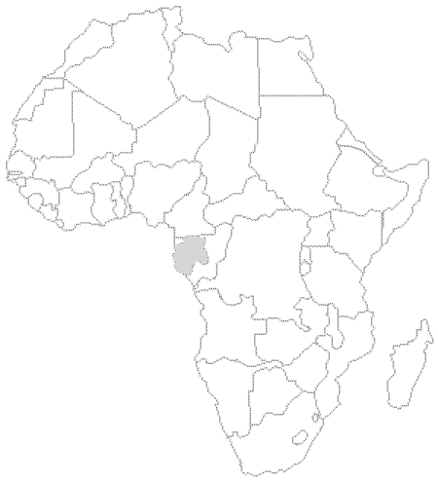Impact of the invasive little red fire ant Wasmannia auropunctata on the Herpetofauna of the West African rainforest.

Travel Dates: Departure from the UK 10/06/2008 departure from Gabon 19/08/2008

Location: Lopé National Park, Gabon

Group Member(s): Amy Beavan, Jamie McWilliam, Emilie van Strydonck, Nicolas Rumboll and Josephine Beynon

Aims: To assess the impact of the little red fire ant Wasmannia auropunctata on the Herpetofauna of the West African Rainforest.

OUTCOME (not less than 300 words):-

In June of this year a team of five undergraduate Biologists and Ecologists from the University of Edinburgh completed a highly successful expedition to the heart of Western Equatorial Africa. Here, a conservation research project was carried out to assess the impact of a globally prominent and devastating invasive species of fire ant, Wasmannia auropunctata on Reptile and Amphibian communities.

Aims

- The primary research goal as introduced above.

- Collaborations with local field researchers and students as well as international experts and authorities.

- Highlighting the conservation importance of the area and the threat to biodiversity posed by invasive species through film documentation.

4) Promote local capacity by working with Gabonese students and local field guides to ensure ongoing research.

The purpose of this preliminary report will be to cover the basic output of our primary research objective. Further details of collaborations and side projects will be covered in the full report.

BACKGROUND
Gabon edged its way into the conservation spotlight around the turn of this century and it fills the criteria for such a position; a large percentage cover of pristine rainforest, relative political stability and several well documented and funded projects. In 1999, Ecologist Mike Fay and photographer Nick Nichols conducted a biological and anthropological research expedition to survey the ecological and environmental status of the region called Megatransect. The results of this expedition were sufficient to prompt the president of Gabon, Omar Bongo to create 13 new national parks in areas noted for their potential conservation and Eco-tourism importance.

Gabon’s rainforests contain an extraordinarily diverse range of flora and fauna. At least 18 animals present in the region, including the endangered western lowland gorilla Gorilla gorilla gorilla and African Forest Elephant Loxodonta cyclotis are recorded on the IUCN Red List of threatened animals (IUCN 2004). 90 vascular plants are also listed as threatened within the country (IUCN red list of vascular plants, 1997). It stands to reason that there are likely to be several large charismatic animals as yet undiscovered. I believe that this is particularly the case for Herpetofauna, a taxonomic group underrepresented amongst the large charismatic animals.

The invasive status of Wasmannia auropunctata

The little red fire ant (Wasmannia auropunctata) is listed as one of the 100 worst invaders in the world by the Invasive Species Specialist Group (Boudjelas et al, 2004). It is native to the continental tropics of the Americas, but, in the last century, global anthropogenic transport has facilitated the establishment of populations in tropical regions all over the world.

W. auropunctata was first recorded in Africa during 1913, in the Gabonese capital of Libreville (Santschi, 1914). Since then the ants have spread rapidly inland, aided by the increased accessibility of the interior of the country. From its origin in Libreville, it has spread in an easterly direction an estimated 390km inland. The largest proportion of this distance was covered in the last 30 years, aided by the logging roads and the railway network.

As human transport within the continent increases through better roads, in particular those penetrating pristine forests for logging and tourism, the rate of spread of the ant is set to escalate. W. auropunctata “may eventually threaten Western Africa’s biological riches to an extent equal to the more tangible threats posed by commercial hunting and habitat destruction. Therefore urgent research is needed in order to discover the underlying impacts this ant is having on Gabon’s biodiversity” (Abernethy et al, 2004).

At Lope National Park, the W. auropunctata infestation has been well documented (Abernethy et al, 2004 and Walker, 2006). There is continuous assessment of it’s spread within the SEGC (Station d’Etudes des Gorilles et des Chimpanzés) centre being carried out by Mihindou and Jeffery who are also in the process of completing ecological impact assessments of the ants on Avifauna and insect communities. This, combined with the fact that there is only very basic inventorial information for Gabonese Herpetofauna comprises the scientific justification for our project.

Sites and Methods

In order to make the assessment, ground dwelling Herpetofauna were used as an indicator group and were sampled in forest and savannah habitats. On going monitoring of the distribution of W. auropunctata within the study area was used to delegate sites. Ten sets of paired sites were allocated for traps; five in infested zones and five in non infested zones.

The traps used for sampling are as shown in Figure 1 below. The lines in the right hand diagram are drift fences and the circles at either end are buckets dug into the ground. Reptiles and Amphibians reach the fence then run/hop along to the end looking for a way through and fall into the bucket. We carried out an initial trial of this method on arrival and found it to be successful in trapping our target group. There is a photograph included in the appendix of one of these trapping arrays in practice.

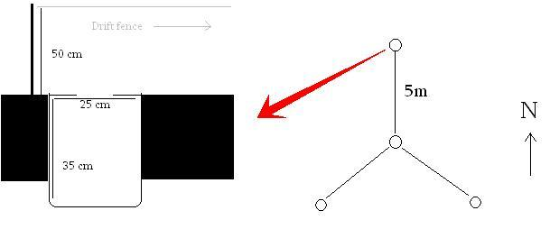

Figure 1: An adaptation of a pitfall array described by Corn and Bury (1990).

Results

The overall trend of our findings can be seen in Figure 2 below. We trapped more specimens in non-infested areas. An ANOVA test was performed on the data resulting in a P value of 0.067. Our results are therefore not statistically significant at the standard 95% confidence interval.

Figure 2: Graph showing specimen counts for infested and non-infested zones.

Verification of specimen species identifications is currently being carried out for Amphibian species but current identification indicates that we trapped four species of Reptile; Brown flanked skink Trachylepsis affinis, White lipped skink Trachylepsis albilabris, Weilers tree snake Dipsadoboa weileri and Gabon plated lizard Gerrhosaurus nigrolineatus identified using Pauwells and Vande weghe (2008). The distribution information in this guide for T. albilabris does not cover Ogooue-Ivindou, the region of Gabon encompassing Lope National Park but we are confident that our identification is correct.

Conclusion
Since the data from this project did not result in statistical significance at 95% confidence. It can be inferred that W. auropunctata is impacting Herpetofauna communities but the P value of 0.08 should be seen in its own right. Statistically there is an 6.7% chance that the trends observed in our data could have occurred by chance. This illustrates that there is an underlying ecological factor responsible for the difference which can reasonably be assumed to be W. auropunctata. As we have the precise locations of our sites mapped and recorded it would be possible for a future project to continue with the study using the current trends as pilot data. I don’t think that this is justifiable under the practical aim of this project which was to inform park management. Our primary collaborator in the field holds an influential management position and will be considering our results which indicate a negative impact of the ants on Herpetofauna in the park.

Acknowledgements
We would like to thank the following organisations and funding bodies for their support of our project; Davies Expedition Fund, James Rennie Bequest and Weir fund of the University of Edinburgh, Royal Geographical Society, Royal Scottish Geographical Society, Zoological Society of London and Carnegie Trust. We would also like to thank all of the teaching staff of the University of Edinburgh for offering their support and everyone else who sponsored or helped us.

References

Abernethy, K.A., Henschel, P., Lahm, S.A., Telfer, P., Tutin C.G., and Walsh, P. D. (2004). Logging speeds little red fire ant invasion of Africa. Biotropica 36: 637–640.

Boudjelas, S., Browne, M., De Poorter, M. and Lowe, S. (2000). 100 of the World’s Worst Invasive Species: A Selection from the Global Invasive Species Database. World Conservation Union, Auckland, New Zealand.

Corn, P. S, Bury, B.R. (1990) ‘Sampling Methods for Terrestrial Amphibians and Reptiles’ United States Department of Agriculture, Forest Service, General Technical Report PNW-GTR-256

Jeffery, K. and Mihindou,V. (2007) ‘Measuring the impacts of the invasive fire ant Wasmannia auropunctata on invertebrates and avifauna in Lope National Park, Gabon’, Proposal for current study in 2008.

Pauwels, O. and Vande weghe, J.P. Reptiles du Gabon. Smithsonian Institution, (2008)

Quammen, David. “Megatransect: Across 1,200 Miles of Untamed Africa on Foot,” National Geographic (October 2000), 2-29.

Quammen, David. “Megatransect II: The Green Abyss,” National Geographic (March 2001), 2-37.

Santschi, F. (1914) ‘Formicides de I’Afrique occidentale et australe du voyage de
M. le Professeur F. Silvestri’, Boll. Lab. Zool. Gen, 8, 309-385.

Walker, K.L. (2006) ‘Impact of the Little Fire Ant, Wasmannia auropunctata, on Native Forest Ants in Gabon’, Biotropica, 38(5), 666-673.

Appendix
1. The centre trap of a pitfall array.

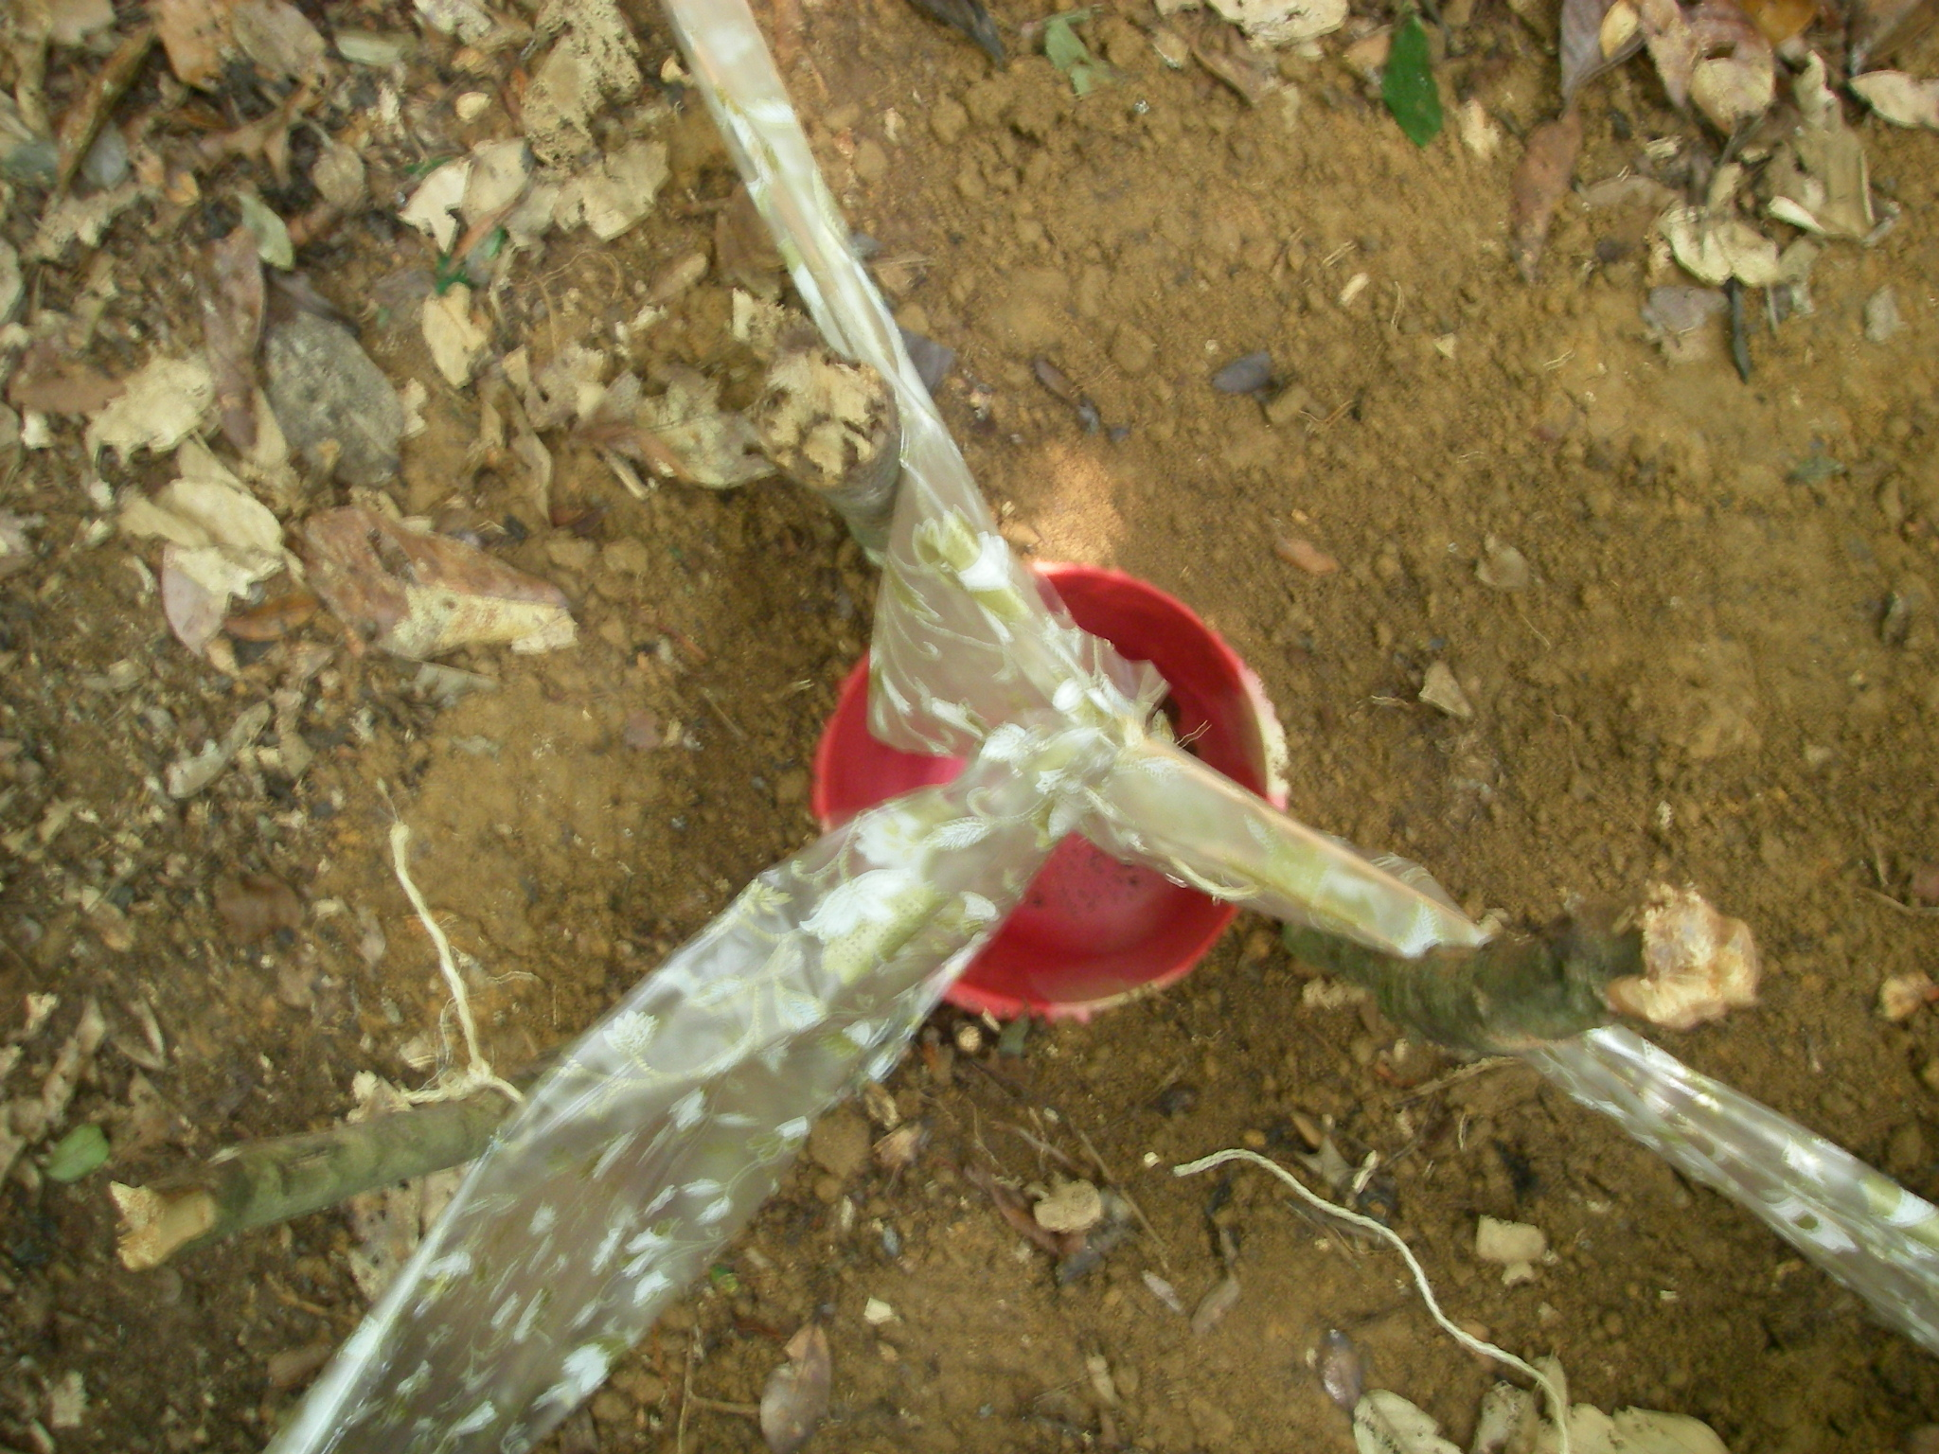

2. Specimen example: Dipsadoboa weileri. Weilers tree snake.

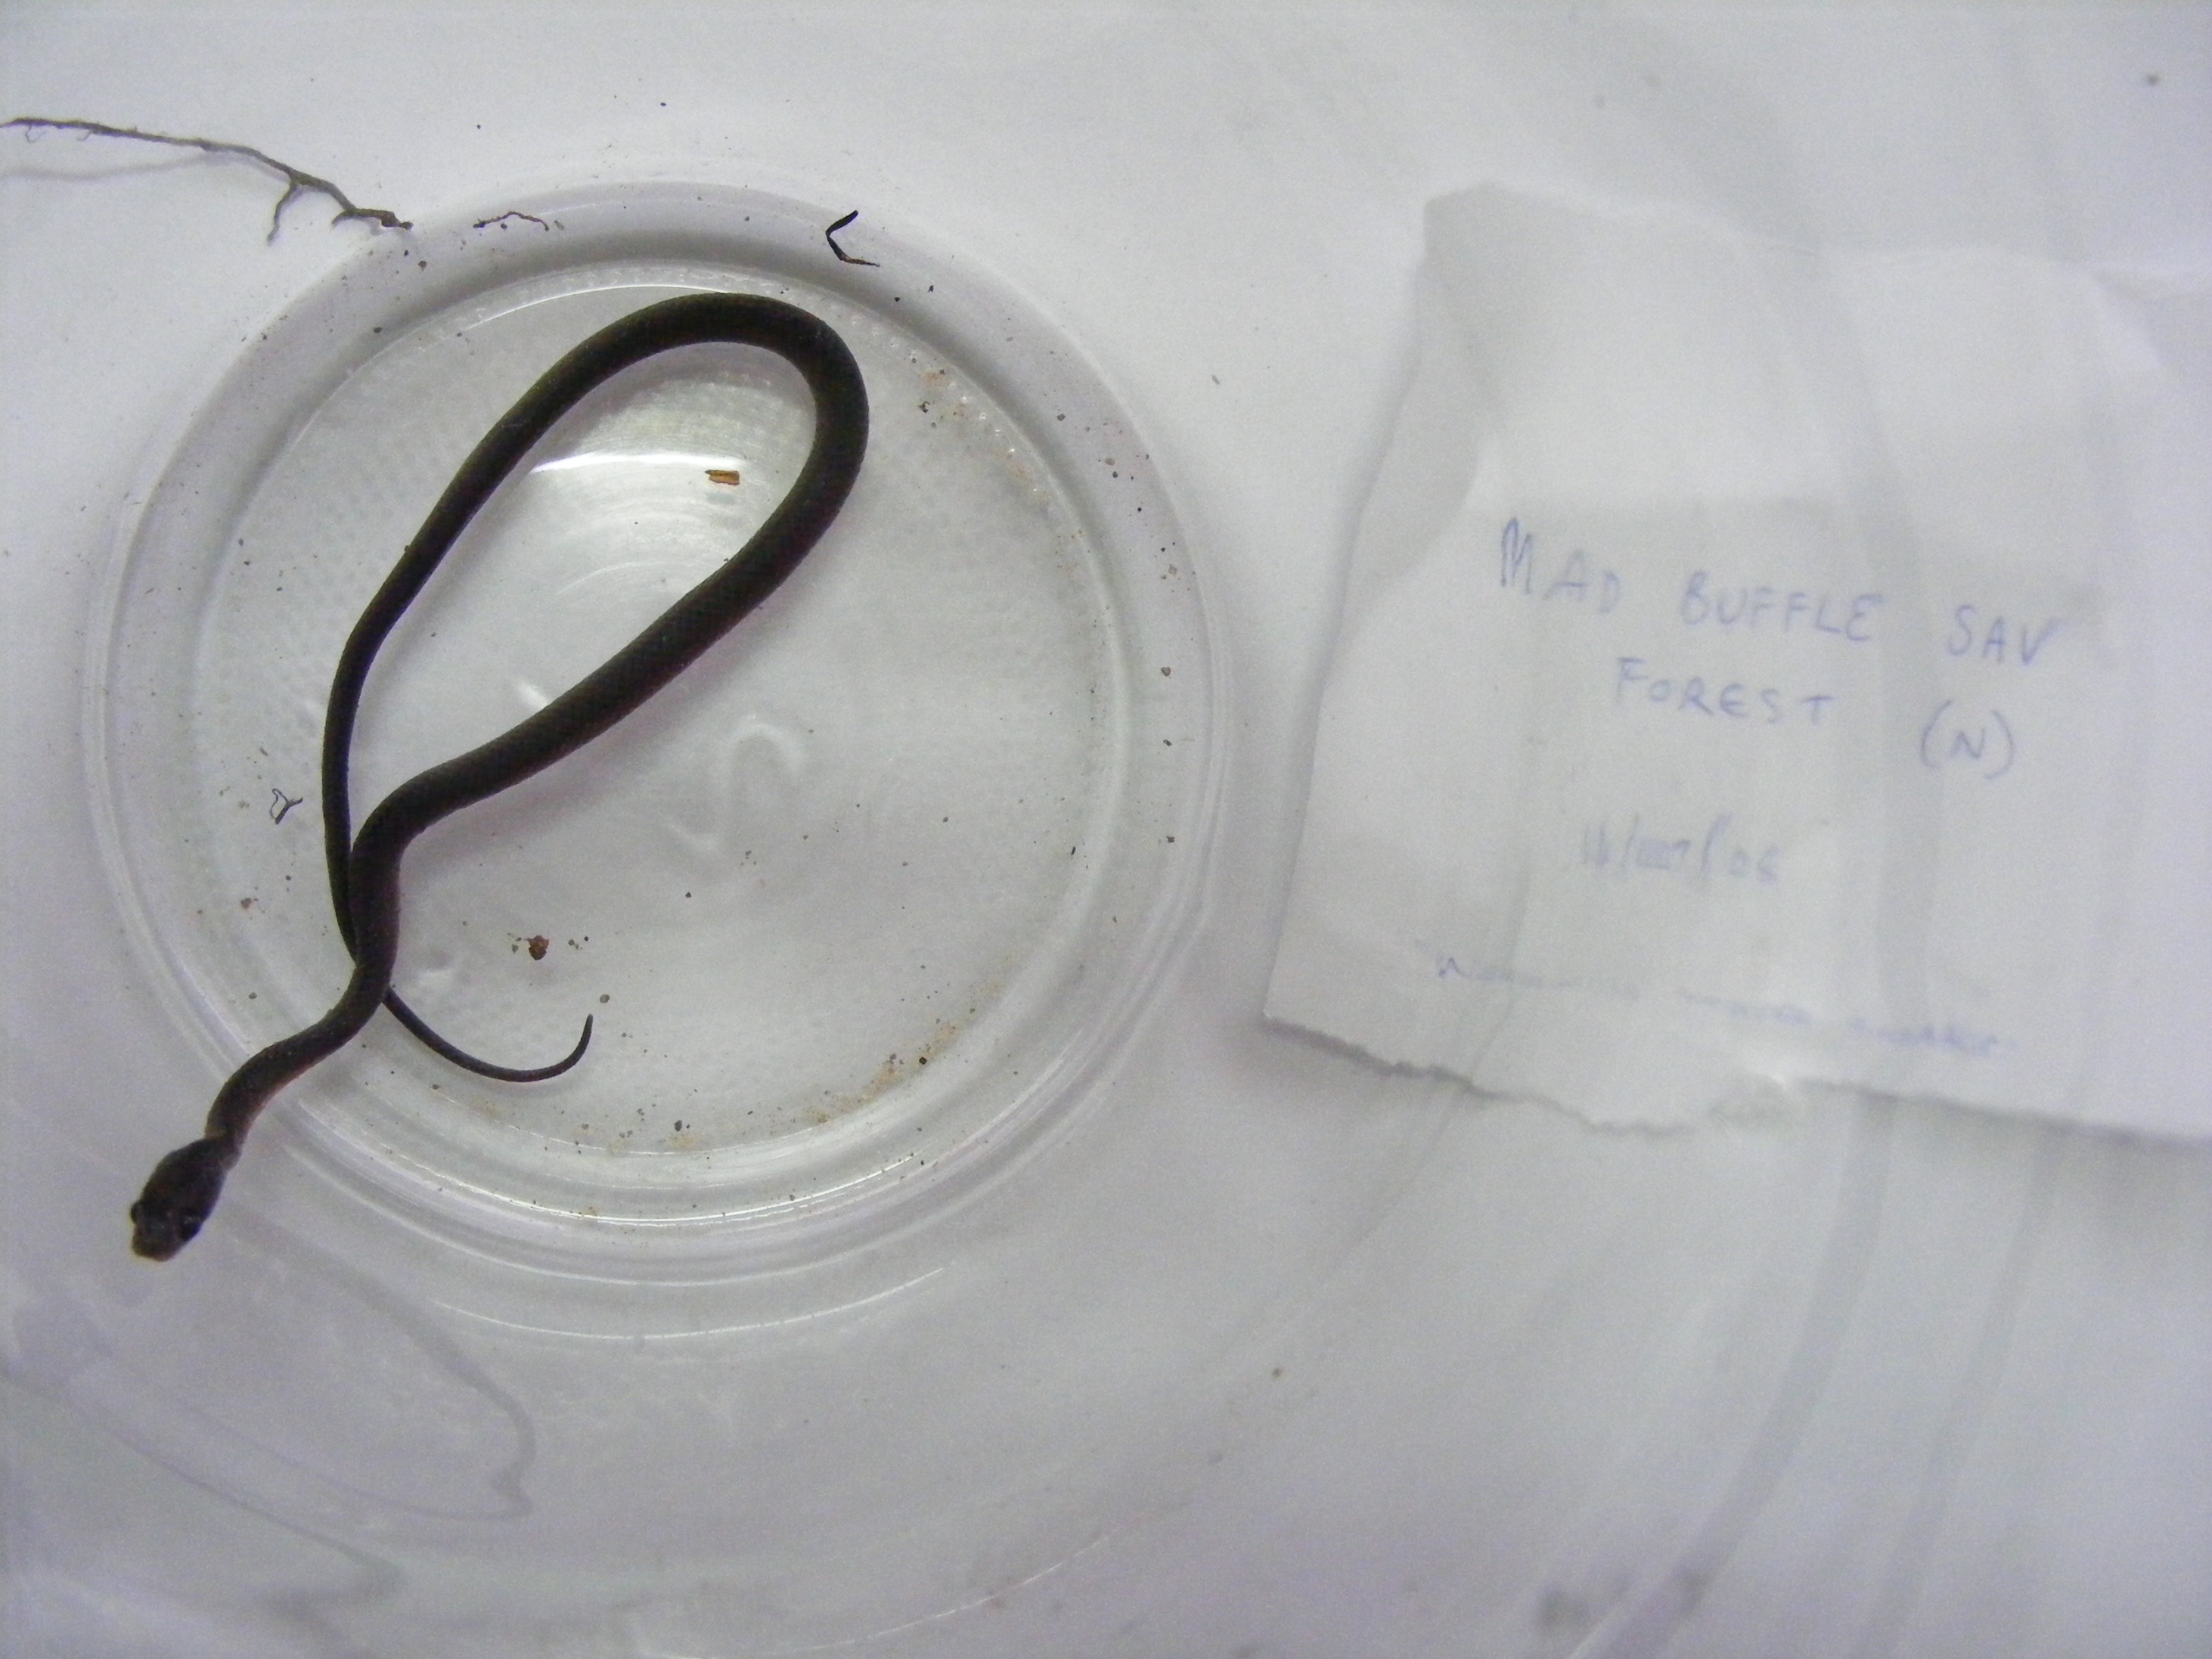

3. GIS map of study area with marked trap sites. 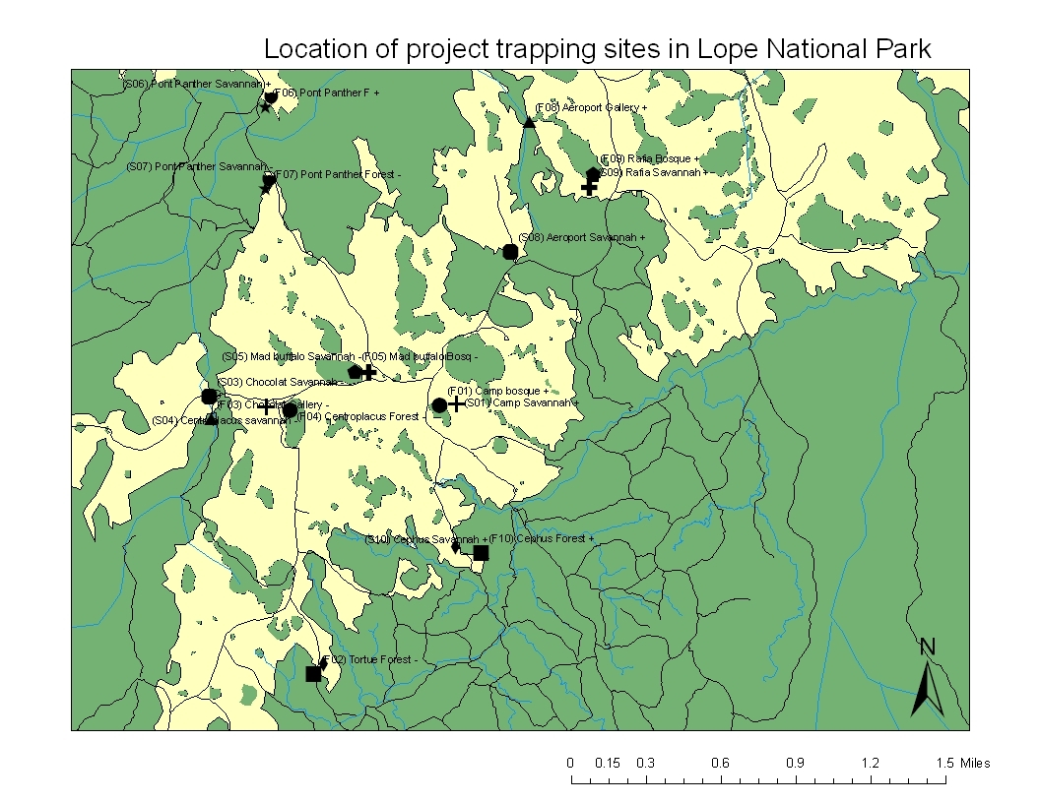
4. The team; right to left Vianet Mihindou, Emilie van Strydonck, Jamie McWilliam, Amy Beavan, Josephine Beynon, Nicolas Rumboll and Dr Kathryn Jeffery.
