Conservation and research of coral reefs in southern Sulawesi, Indonesia

July - September 2005

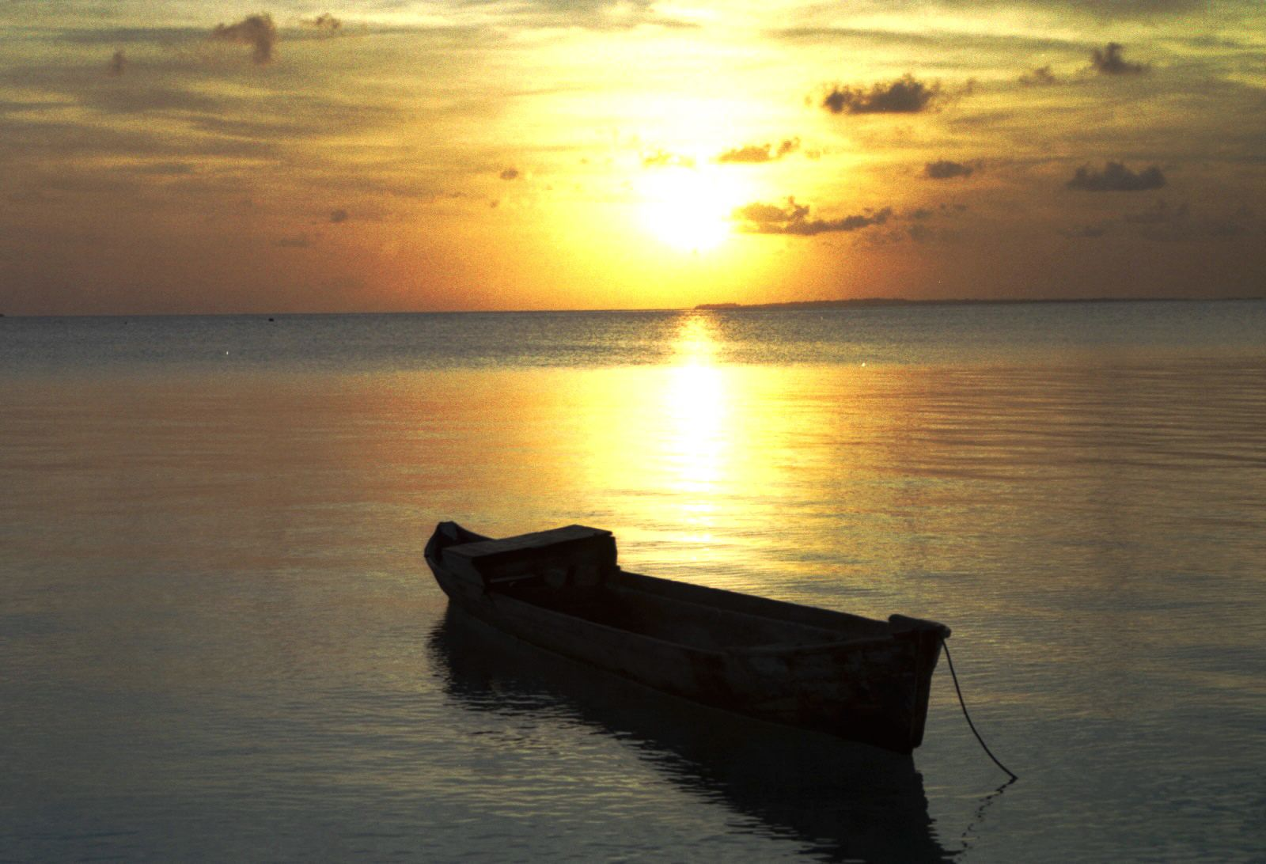

Introduction:

Operation Wallacea is a charitable trust established to support research and activities that contribute directly towards the conservation of habitat, biodiversity and sustainable development. One of the five large research sites the trust incorporates is based on the islands of Kaledupa and Hoga, which are both within the wakatobi marine reserve. (Figure 1)
The work done there is directly concerned with researching the coastal regions around the island of Sulawesi, in the centre of the Indonesian archipelago. The waters of Indonesia and the Philippines have some of the most biologically diverse and abundant coral reef systems yet discovered on the planet. It is therefore an extremely important task to increase the knowledge of the life-forms within the area, and the dangers to their health. The project also works closely with the local communities that live in this area, implementing sustainable fishing strategies such as a marine protected area (MPA), and educating them about the reef wildlife. This can hopefully help protect the delicate ecosystems, whilst maintaining the traditional ways of life that exist here.
After 9 years, Operation Wallacea, in collaboration with biologists, environmental scientists, social scientists and anthropologists, has achieved much. Recent achievements include:

- The designation of the entire Tukangbesi archipelago as a Marine National Park – an area larger than Greater London.
- The discovery of 20 vertebrate species new to science in Sulawesi’s threatened rainforest.
- The development of sustainable sources of income with the local community, replacing environmentally destructive prior practices.
- The establishment of strong links with local conservation bodies.
- The publishing of more than 25 scientific papers in peer-reviewed journals every year as a result of expeditions like mine.
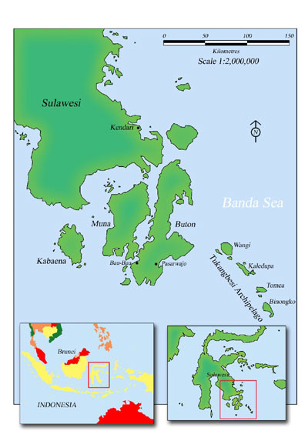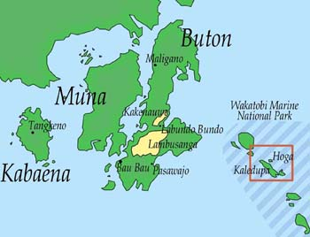

Figure 1: Maps of location of Hoga island in relation to Indonesia as a whole
.
Whilst working as a volunteer for Operation Wallacea, I was given the opportunity to work with other scientists to learn about and research the life forms that exist within the region, to monitor the long term state of the reef, and see to what extent they are changing due to anthropogenic influences.

Before permission to aid scientific research was given, each researcher and volunteer are given extensive scientific training to guarantee the information collected is valid. They also have to complete a coral reef ecology course, specifically for the Indo- Pacific region. This was comprised of 3 main tested sections: Fish species, coral species, benthic forms & invertebrates. The aim of this was so that we could competently identify the majority of life forms that what we were investigating. This was usually down to genus level, or species level if possible.
The course also covered all indicator species used to perform a Reef Check survey. This is a global initiative to survey, (using basic line intercept transect techniques), all reefs around the world. The surveys should give a general overview of the reef’s health and is specific to certain marine regions round the world. This can be compared on a global scale overtime, and is very important for a general view of what is happening.

Projects involved with during the expedition:

Coral growth, recruitment and disease
The main project I was involved with was aimed at fulfilling one of the conservation management objectives set out by Operation Wallacea to complete whilst working in the area. This was: ‘To ensure that the biodiversity of the reefs remains at current levels or improves.’
This is separated into five areas:
- To ensure that the diversity of hard coral species remains at the same level or increases particularly in areas where there has been damage.
- To ensure that the percentage of hard and soft coral cover remains the same or increases particularly in areas where there has been damage.
- To ensure that the growth rate of hard coral species remains the same or increases.
- To ensure that the average size and diversity of commercially exploited mollusc and echinoderm species remain constant or rises.
- To ensure that the diversity and abundance of reef fishes remains the same or increases particularly in areas where there has been damage.

‘For the past 3 years Operation Wallacea have implemented a detailed coral reef monitoring program with aid from the Indonesian Institute of Science staff. 108 permanent transects have been placed around the islands of Hoga and Kaledupa and these transects have been assessed for coral diversity and fish diversity. The repeated measures of each transect have allowed to examine the rates of change in key community parameters and hence has enabled us to quantify the success of our management objectives.’ (Operation Wallacea)
Our tasks were to survey many of these transects and lay new ones to look at changes in:

- diversity and abundance of benthic, life including corals.

- Extent of ‘coral bleaching’ evident within the region.

- To observe reef fish relationships with table Acropora sp. coral

- To help measure growth and recruitment rate of coral in a direct measurement manner.
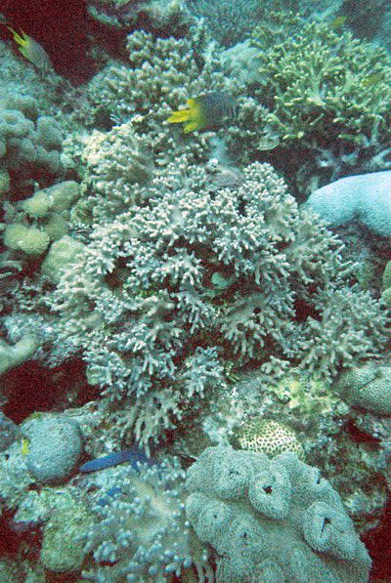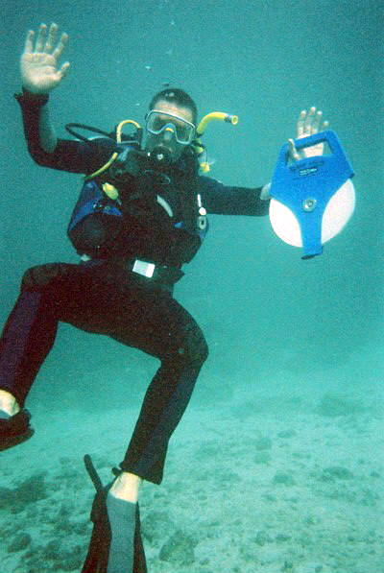

An example of the highly diverse mixture of hard and soft My diving buddy ready to lay the transect tape for a suvey. corals found within the Wakatobi park.

Fish standing stock surveillance, type and abundance
This project consisted of direct observation of all fish species present along multiple 20 metre transects at various dive sites around Hoga and Kaledupa. Any fish observed within a 5 x 5 metre viewing range along the transect were recorded. The data was then used to assess long- term fish standing stock trends within the area, to see if over-fishing is occurring and to determine the effectiveness of the marine protected area.

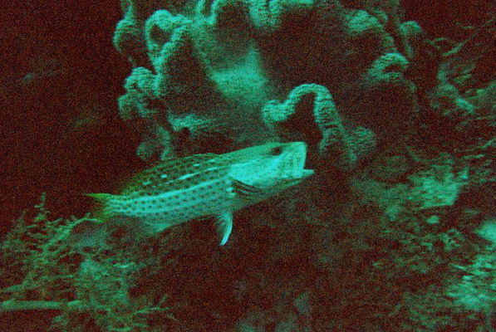

A snapper looking for a bite to eat!

Reef check, specifically benthic forms on live-aboard research vessel
During the penultimate week of the expedition, a group of us took part in a Reef Check survey on a live-aboard research vessel. The route taken started in a southern direction around the island of Kaledupa and then headed Northward around the island of Wanci, all still within the marine reserve, however far less charted by marine surveyors. The purpose was primarily to complete fish, invertebrate and benthic Reef Checks at multiple depths, to add to the global database, but also secondly to attempt to observe any megafauna/ large mammal activity in the area. Both these activities could help the effort to preserve the Wakatobi region from degradation if important endangered species are observed within it.
‘Diadema (Sea urchin) abundance and diversity and invertebrate communities within the mangroves
Finally, I also took part in some of the dissertation student’s research collection, which gave extra experience of other important areas found within tropical coastal regions, specifically the mangroves and seagrass beds.

Extra activities:

Whilst working, I also had the opportunity to complete my PADI ‘Rescue diver’ and ‘Emergency First Response’ First Aid qualifications. These are an important step to becoming a professional diver, and therefore being competent in diving technique for research work.

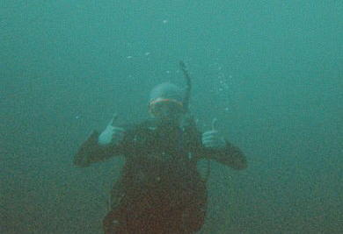
Me during a dive!

Outside of research diving on days off we had the opportunity to visit some of the local islands and communities within the area. Further toward Kaledupa island is the fairly recently constructed village of Sampela. This belongs to the Bajo fishing community. Once ‘sea gypsies’ they have now settled in the area and Opwall are working with them to educate them about the diverse habitat they live in to try to prevent destructive fishing and initiate cooperatives to maintain viable fish stocks in the area. The MPA is just one example of the many methods employed.

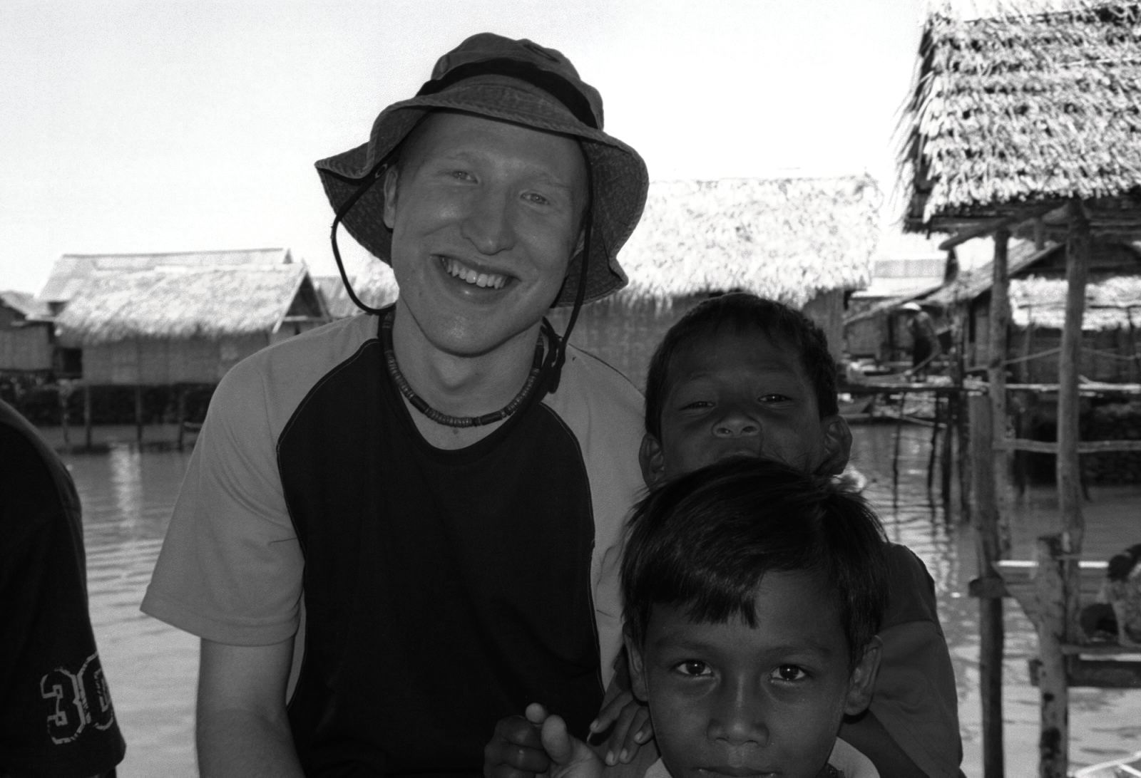

Me with some of the children from the Bajo community on the village of Sampela

Many thanks are given to the James Rennie Bequest for their generous contribution and to Operation Wallacea for the expedition and use of their web resources in writing this report.

Daniel Bayley

