Conservation and research of coral reefs in south western Madagascar
June/July 2004

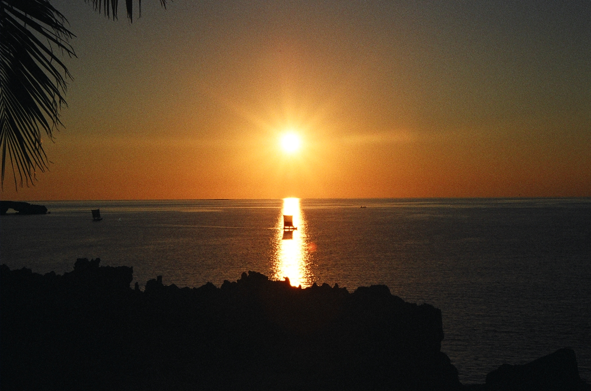

Introduction:
Blue Ventures is a conservation charity based in the UK, with a permanent field research site situated next to the small coastal village of Andavadoaka, just north of Toliara in South western Madagascar.
Andavadoaka ‘lies on the edge of a shallow lagoon, protected from the open ocean by the reefs. In addition to the extensive fringing reefs, several banks rise up in the lagoon, and a series of uninhabited offshore islets and submerged barrier reefs also support substantial coral growth, providing a vital resource base for local traditional and artisanal fisheries.’
‘The project was launched as a collaborative venture between Blue Ventures Conservation and the Institut Halieutique et des Sciences Marines (IH.SM) in response to the need to develop a better understanding of the area’s unique marine and coastal habitats.’
‘Owing to their remoteness and isolation, and the large distance of the Andavadoaka reef systems from the nearest scientifically-studied reef habitats in south-western Madagascar (situated in the Ranobe region some 250km south of Andavadoaka) these coral reefs are thought to possess a significantly different and higher abundance and diversity of species than other reefs in Madagascar. Despite the uniqueness of this marine habitat, no data on the status of the reefs existed prior to the establishment of our research site in the area.’- (Quoted Blue Ventures)

Work done:
During my stay as a volunteer researcher for Blue ventures during the summer, many projects were undertaken. This was part of a continuing effort to increase the knowledge of the abundance and diversity of benthic and limnetic marine forms around the south western coast of Madagascar. Along with data collected concerning coral and fish species, we also undertook mapping projects of the reefs, islands and mangrove plantations, participated in teaching of English and ecology to the local villagers, conducted octopus surveys, and tried to increase our understanding of ‘traditional ecological knowledge’ by observing fishing methods and talking with the villagers.

Baseline surveys:
Each day, a maximum of 2 dives were performed by each volunteer, undertaking a range of ‘point intercept transect recording, fish belt surveys and reef mapping.
A point intercept transect is where all benthic forms that cross a 10 metre transect line are recorded and entered into a database. A total of 79 of these transects were performed by us over a total of 9 underwater sites. This helps to give an indication of reef health (if most points along the transect were covered with algae or were dead/ bleached coral, the reef would be considered very unhealthy), and they also give an idea of just what is there! This data was then joint with data collected by three other conservation groups in the nearby area to give a large scale view of coral reef health.
Coupled with the benthic transect data, 41 fish belts were performed, where any fish that is observed within a 5 metre by 5 metre view range along a 20 metre transect, is identified to species type and measured in abundance.

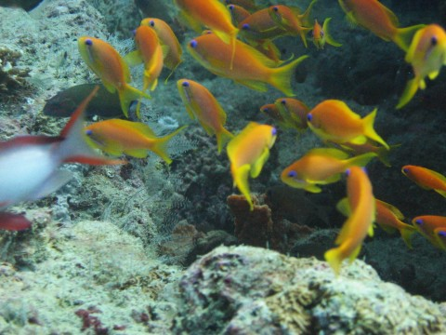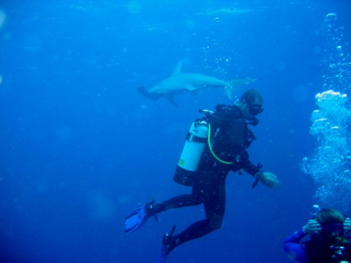
Example of fish belt, with a shoal of damsel fish An unexpected hammerhead shark encounter!

To make sure all observations were scientifically valid, we were extensively trained in underwater organism identification, and a number of tests had to be completed before data was used.
Due to the observations of volunteers, along with verifying previously observed species, around 30 species have been observed around Andavadoaka, which are either new to south west Madagascar or to Madagascar as a whole! Photography and specimens are now being collected to help the ‘Institut Halieutique et des Sciences Marines’ identify new species and aid learning of ecological forms for the local people.

Mapping:
Whilst most of the research was focused on species identification and abundance surveys, we also conducted underwater mapping exercises. This involved a group of 6 divers working as a team to outline the lay-out of reef patches around Andavadoaka using GPS and tape measurements, joint with major reef object observation (such as large tabular coral or boulders).
Island and mangrove mapping were performed in a similar fashion, using GPS and observational technique. 5 species of mangrove were observed and a general outline of the ‘mangel’ was recorded.
WWF has identified the small islands off of the western coast of Madagascar as a conservation priority, so during our stay we completed a GPS and visual survey of the local island ‘Nosy Hao’, measuring the littoral zone at spring high and low tide and recording dominant flora types. We also added to a basic bird inventory (both on the island and around the mangroves). 10 species of bird were found on the island, along with a nesting colony of ‘dimorphic egrets’ on the north end of the island. There is also the possibility of a nesting site for green turtles on the island, which would make the island one of only two confirmed nesting sites in south western Madagascar.

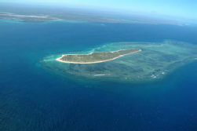
Aerial photo of Nosy Hao island and surrounding reef flats.

Octopus surveys and traditional ecological knowledge:
Another aspect of our work was conducting surveys of the weights and abundance of squid and octopus collected by the local villagers for sale to a fishing corporation called ‘Copafrito’. This corporation sends a storage boat to Andavadoaka every month on the full moon to collect the fish, octopus and squid caught. This has caused a large increase in fishing pressure in the area, and a detrimental effect to the coral reef flats due to the destructive nature of this type of fishing technique. This continued pressure on the octopus population appears to be unsustainable, even though the local community relies heavily on the profits made.
Surveys were also conducted regarding the type of fish caught for the corporation and the whereabouts of their capture. This will help to see where the main fishing pressures are in the area and how the populations are reacting to that force. This information can be used to help install the marine protected area, which is planned for the waters near Andavadoaka, to help combat the decline in marine stocks.

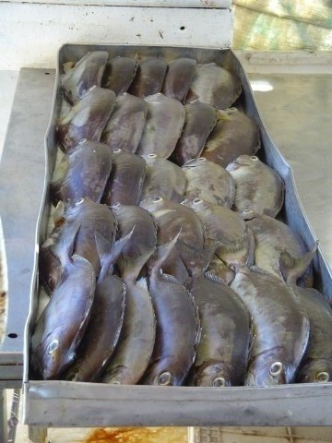
A collection of Rabbit fish for sale to the fishing corporation ‘Copafrito’

Teaching:
A final aspect of the project was to help teach basic English and ecology to the local village and in return we were taught basic Malagasy and were able to exchange ‘traditional ecological knowledge’ with them. We also surveyed fishing techniques and methods used by the village fishermen, who are renowned in Madagascar for their knowledge of the sea and sailing. It was very rewarding to help teach the villagers a skill such as English, which they can use to perhaps help in a career of eco tourism in the area.

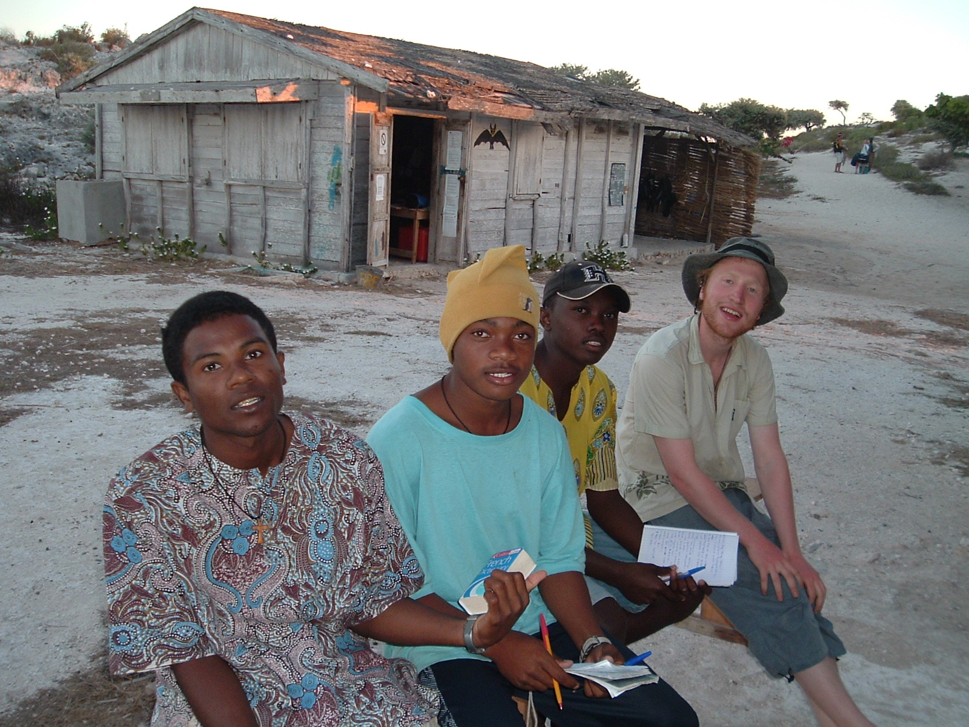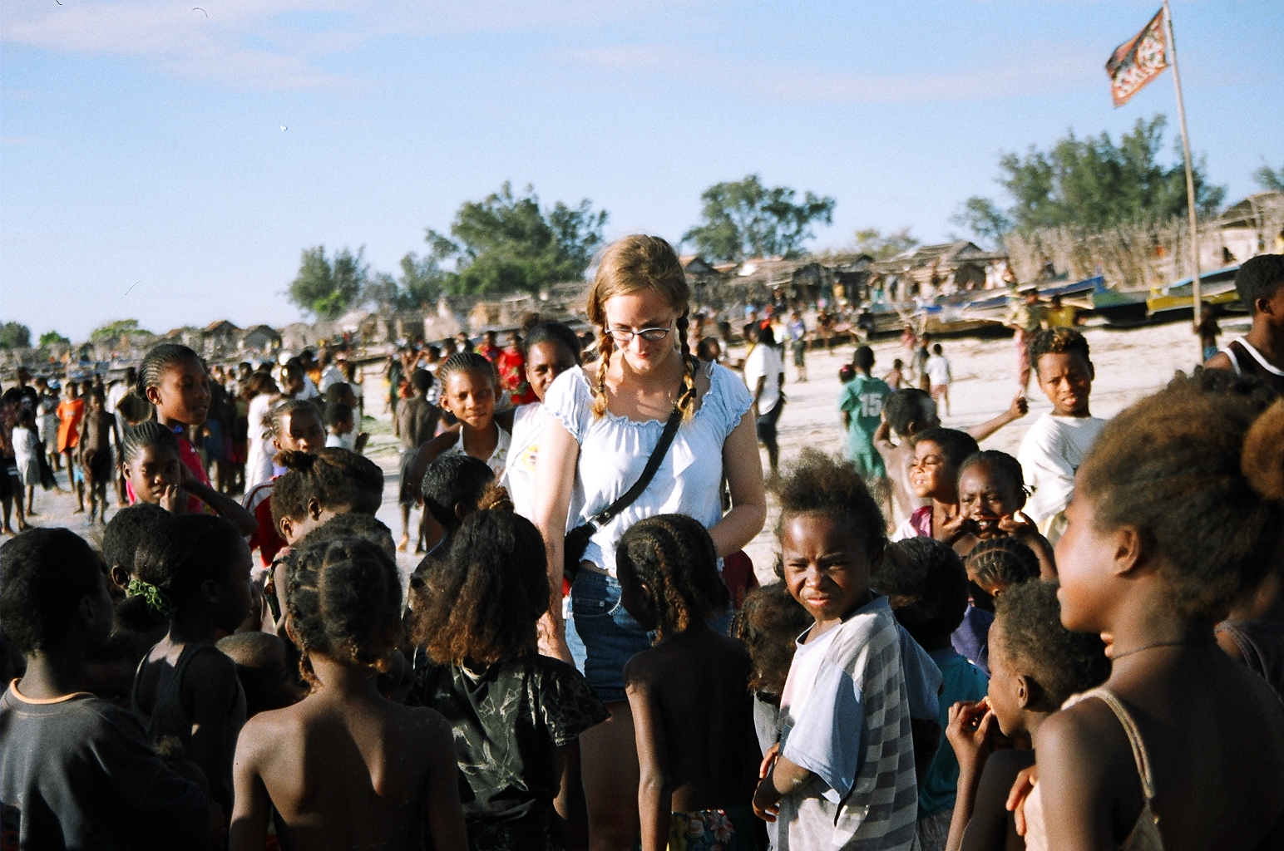
Me & 3 of my Malagasy students An impromptu lesson on the local beach

Summary:
Valuable research regarding species abundance and identification was performed and is continuing to be collected from the site in Andavadoaka. This will be used to help ascertain exactly what exists within this previously un-researched area. It will also be used to help promote sustainable fishery management (including the installation of a marine protected area), and the improvement of knowledge in the area regarding coral and other marine animal’s value. ‘Blue Ventures’ is also working towards the possible future of eco-tourism in the area as an alternative to fishing.

Acknowledgements:
Many thanks to the James Rennie Bequest for their generous money donation, and to ‘Blue Venures’ for the use of some of their imagery and resourses for this report.

Daniel Bayley

