JAMES RENNIE BEQUEST

REPORT ON EXPEDITION/PROJECT/CONFERENCE

Expedition/Project/Conference Title: Kinetoplastid Molecular Cell Biology International Conference

Travel Dates: 21st April – 1st May 2007

Location: Woods Hole, MA, USA, and Yale University, CT, USA

Group Member(s): Eleanor Barnwell

Aims: To present a poster on my work at an international meeting, and to visit a lab at Yale University

OUTCOME (not less than 300 words):-

I would like to thank the James Rennie Bequest for enabling me to attend this meeting. It is a key meeting in our branch of science and was attended by many of the leaders in the field of trypanosome biology.

After a weekend in Boston to recover from jetlag, we travelled to Woods Hole, which is on Cape Cod, and is a beautiful and tranquil setting for a conference. The Marine Biological Laboratory in Woods Hole has a historical association with parasite biology, hosting not only these conferences, but also the annual Biology of Parasitism course, which is very highly regarded. The conference began with a talk by the conference organiser and well-known trypanosome biologist George Cross on antigenic variation in trypanosomes. This seemed a very suitable way to start off the conference. This was followed over the next three days by sessions on cell biology, biochemistry, gene expression, life cycles, and kinetoplast structure and expression. Particular highlights for me included Professor Wendy Gibson’s talk on genetic exchange in trypanosomes which contained some really beautiful microscope images, and Laura Cliffe’s talk on base J. Sam Dean from our lab gave a talk on a protein implicated in differentiation in trypanosomes and this was received with a great deal of excitement. One discussion about what components of human serum are responsible for lysing trypanosomes descended into a barely civil debate, which included mention of who had had a love affair with which scientist! It was fascinating, having been aware from the literature that this was a hotly debated topic, to see the scientists involved argue their points. I have to admit though that after all this heated discussion, I did not have a much clearer idea in my mind as to what is actually going on!

I presented my poster entitled “A developmentally-regulated expression-site associated gene in bloodstream form Trypanosoma brucei: A pre-adaptation for parasite transmission?” on the final evening of the conference. I had a constant stream of delegates visiting my poster, including some of the leaders in the field such as Keith Gull, Dave Barry, and George Cross. I got a lot of feedback about my work, which was very useful. Much of the feedback was positive, but also I was given advice on how to improve experiments and include the best controls, and this will help me to plan my future work. These are some of the people who might review a paper on our work so it was especially helpful to hear their thoughts. As luck would have it, the poster next to mine was presented by a girl working on the gene ESAG5 (I am working on ESAG9) so I was also able to compare notes with her about the gene and protein expression profiles and other characteristics of our gene families. It was nice to be able to discuss my work not only with lab heads, but also with my contemporaries who are at the same point in their career as me. Various useful conversations happened over breakfast, coffee, drinks in the pub and so on.

After the conference I then travelled to New Haven to spend a day in the lab of Professor Serap Aksoy at Yale University. Professor Aksoy works on many aspects of tsetse fly biology, including tsetse-trypanosome interactions. It was extremely useful to meet with her and discuss experimental approaches for exploring the interesting dynamics of trypanosome infections of the tsetse fly midgut. We discussed various protocols, culture conditions, and possible ideas for future experiments, and I think that Professor Aksoy also found the meeting useful. I met with other members of her lab to discuss mine and their projects, which was very interesting. I am sure I made some contacts at Yale that I will be able to utilise in the future.

So to summarise I found both the conference and my visit with Professor Aksoy extremely interesting and inspiring. Since returning to the lab I have already implemented ideas that I had discussed with various people, and I have some interesting new data as a result.

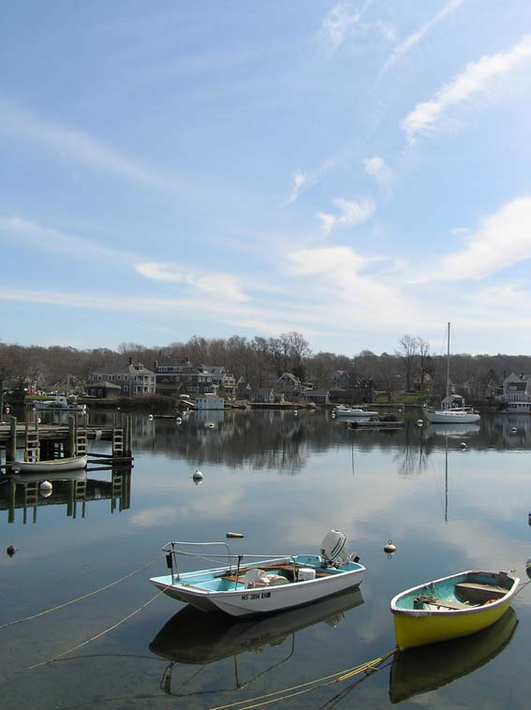
A view from the conference centre

