JAMES RENNIE BEQUEST

REPORT ON EXPEDITION/PROJECT/CONFERENCE

Expedition/Project/Conference Title: Darwin Primate Group Voluntary Work and Field Research

Travel Dates: 2nd June to 2nd July 2010

Location: The Crags, Natures Valley, The Garden Route, South Africa

Group Member(s): Leanne Barnes and Molly Mouland

Aims: To experience firsthand research and rehabilitation work involved with baboons and vervet monkeys in South Africa. To gain knowledge of the conservation and behaviour of these monkeys through local knowledge, working in a rescue centre and field research. Satisfy a lifelong dream of working with primates and helping where humans have caused strife in their lives.

OUTCOME (not less than 300 words):-

In the summer of 2010 we volunteered at a primate rescue centre in South Africa. The Darwin Primate Group is an organisation set up to rescue orphaned and injured primates of South Africa; vervet monkeys and chacma baboons.
Whilst there we helped with the day to day care of the monkeys including cleaning cages, feeding and washing dishes. We also collected branches and created other enrichment activities. There were 32 vervet monkeys at the centre ranging from fully grown adults to this year’s babies, most of which lived in the forest around the centre as a combined troop. A few of the handicapped monkeys were unable to be a part of the group so they often became foster mothers to the orphans and were let out with supervision.

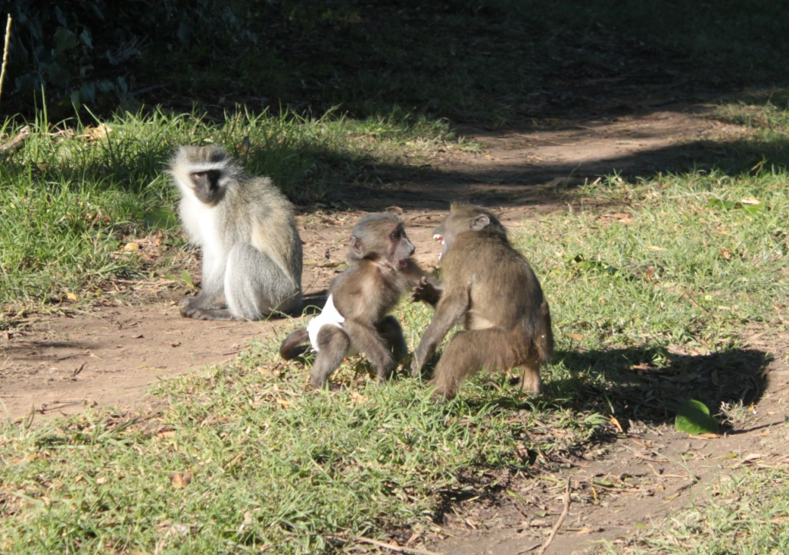
During our time there we were able to take part in a number of different activities including anti-snaring patrols and development of the educational material available to the local people. After being at the centre for 2 weeks we were called to rescue a baby baboon that had been abandoned in a village and was found by a game park manager of a local private game reserve. This gave us a new inside perspective on the political issues and animal rights violations that occur in South Africa, not only by the local people but by over stretched conservation groups. We arranged to collect the baboon and bring him back to the centre. As baboons stay with their mothers for about a year and this baby was thought to be about 4 months old, we took on the responsibility of being a temporary surrogate mother until he had settled in and bonded with the others.

Right: A photo showing George the vervet monkey watching Bean (left) and Gumble (right) playing.

As Karin Saks is the only permanent resident at the centre and was already a mother to another baboon called ‘Gumble’ it was decided that the best course of action in this instance was to try and get the new baby baboon ‘Bean’ and Gumble to bond, allowing them to hopefully be rehabilitated together.

Bean was found in a very dehydrated and malnourished state so initially a lot of time was needed to get him back to being reasonably healthy as fast as possible. Integration of him into the monkey troop was amazingly easy as he proved to be very independent. Bonding with Gumble was slightly harder as both baboons had very little social skills with their own species but eventually they came to be reliant on each other.

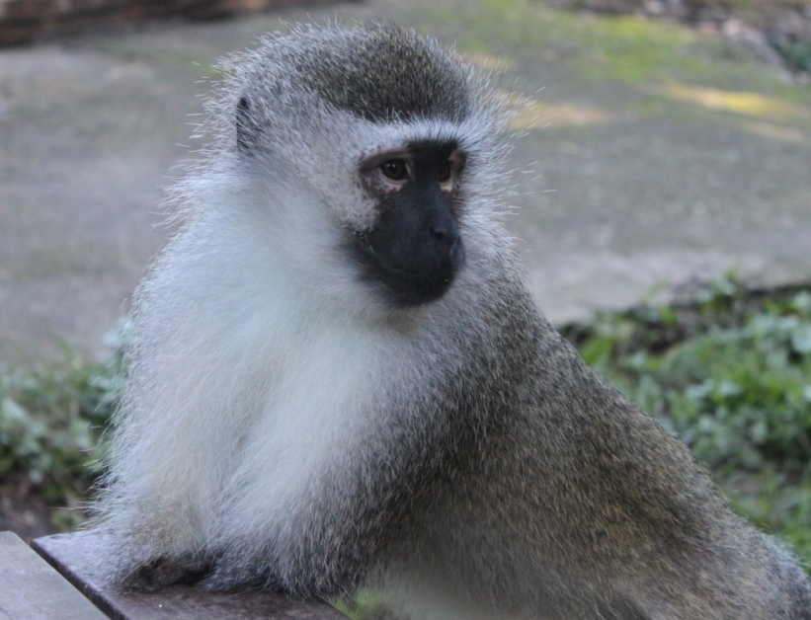
We learnt a great deal about troop structure, hierarchy and behaviour of vervet monkeys through watching the social interactions between individuals in the troop. Vervet monkeys are matriarchal with a dominant male who ‘leads’ the group, yet this male only has power if he has the support of the troop females. Through observation we learnt to identify each individual as they all proved to have very different characteristics and personalities. Once we were able to distinguish between them all, the troop hierarchy became very apparent and as we spent so much time with the group we also had to establish ourselves within the troop. The dominant male was rescued from a local town, Knysna and was called ‘Mr. No-Hands’. He was found with his lower arms missing after getting caught in a snare. Due to the fact that vervet monkeys have a quadrupedal movement this presented a great challenge, yet he has learnt to walk, run and climb in a bipedal manner so successfully that he has been able to gain his position as the dominant male.
This highlighted to us the ability of the monkeys to adapt to many situations using intelligence to overcome huge challenges and difficulties, largely imposed upon them by humans.

Right: Mr. No-Hands strikes a pose

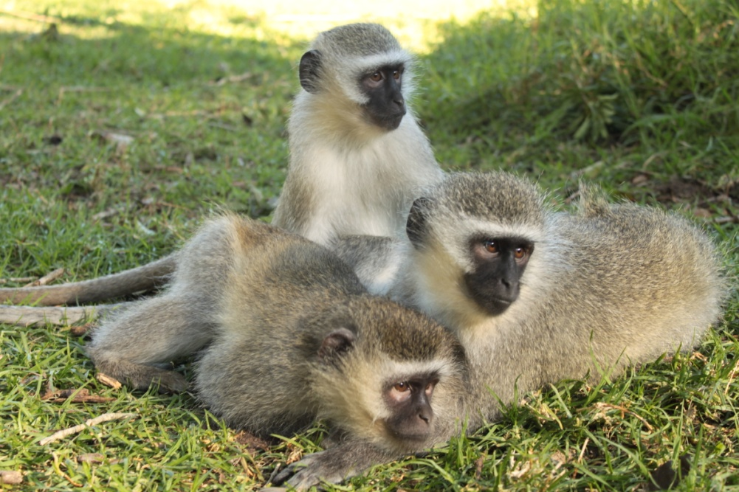
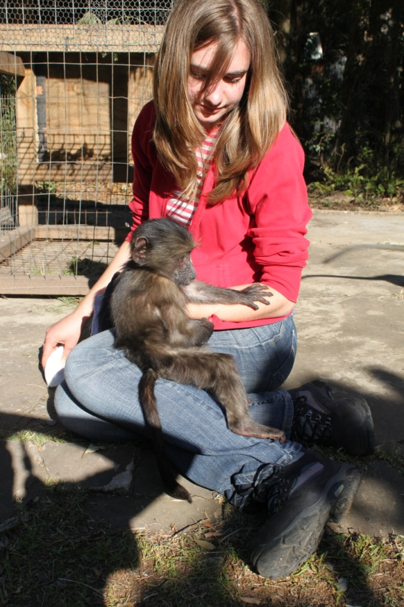
Due to the forest location of the centre, there was also a wild baboon troop that would travel through the site on a regular basis. This enabled us to get a close up first-hand experience of a wild baboon troop that is thought to be over 40 strong. During their visits we were able to begin the rehabilitation process of the orphaned baboons, initially by staying in a cage with them for support whilst the wild baboons fed outside the cage. This began communication between the troop and the orphans. The leader of the centre, Karin Saks has developed a close bond with the wild troop, enabling her to be accepted as part of the group.

Above: Koko, Mango and Zambi enjoy a grooming session.
Left: Molly with baby baboon Bean
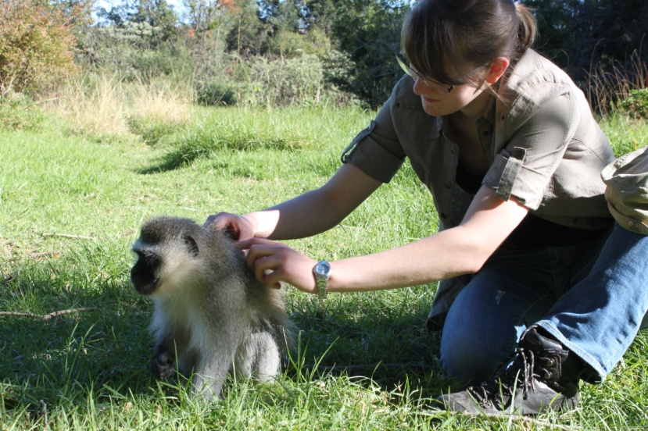
This in turn has meant that she has recently been able to start the integration of the orphans to the group who are now able to play with other babies in the wild troop when they come through the centre. It is hoped that these orphaned baboons will be the first ever to be successfully integrated back into an established wild troop.

Left: Leanne grooming George

During our stay we were able to gain a different perspective on the country as a whole and the complex political issues surrounding both humans and wildlife. Whilst there we were lucky enough to be taken to a local township where there is a huge amount of poverty in the community, highlighting the enormity of the divides between rich and poor in this country. In these townships there would be bags of rubbish left out for collection that would be raided by wild baboons. This would therefore cause hostility towards the baboons through no fault of their own or the local people.
The plight of the country’s native primates was again shown when farmer’s crops would be raided for food, by animals that have had their natural habitat destroyed in order to make space for the farms. Due to raiding, the government has instated legislation allowing each farmer to legally shoot 10 baboons per day. This causes huge devastation to troop numbers and creates large numbers of orphans due to people’s willingness to shoot adult mothers, leaving their babies behind.
Another issue highlighted was an unwillingness to insulate cables and pylons or create underground cabling for the country’s electricity supply. This means a large amount of monkeys are electrocuted by landing on and getting caught up in these cables, meaning the rescue centre now has to operate with no mains electricity supply, to prevent the troop injuring themselves.

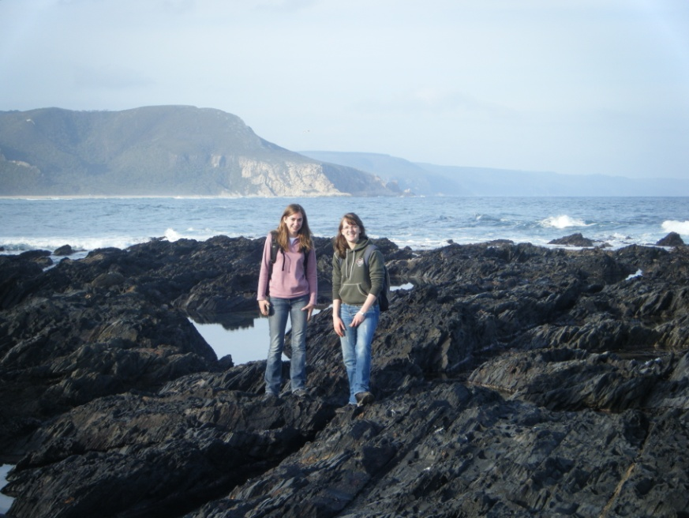
The majority of our time was spent at the centre however we were also able to explore other parts of the garden route. We managed to take a trip to Addo elephant park and the Garden Route Game Lodge where we got to see some of Africa’s more famous wildlife; the big 5. We also saw some of South Africa’s stunning scenery including Storms River Mouth, Natures Valley and the Robberg Nature Reserve. Our time in South Africa coincided with the world cup so we couldn’t

Right: Our trip to Natures Valley beach

resist a trip to Cape Point and Cape Town where we went up Table Mountain, visited the Simons Town African penguins and Hout Bay seal colonies. We also attended a talk taking place locally about the secret elephants that are supposed to be living in the Knysna forests and surrounding land. These elephants are a hot topic and lots of debates continue now as to the numbers that exist as they are the last truly wild elephants to survive in South Africa. A few fossilised elephant teeth had been found on local farm land so this has sparked a debate as to their origin.

We had an amazing experience while in South Africa and will cherish the memories for a life time. It allowed us to fulfil lifelong dreams and opened our eyes to the complex and diverse world that surrounds us. We would like to thank everybody involved with the James Rennie Bequest for making our trip possible as it has inspired us to continue working towards careers in primates and conservation.

