REPORT ON EXPEDITION/PROJECT/CONFERENCE

Expedition/Project/ Conference Title: | Operation Wallacea Madagascar
Travel Dates: | 5th July-6th August 2012
Location: | Mahavelo, Ifotaka Madagascar
Group member(s): | Sarah Aldous
Aims: | To assist in Data collection for WWF on the ecological management of the protected area, and the effect of local disturbance on several species communities as well as contributing to IUCN lists
OUTCOME (not less than 300 words):-

During the summer with the assistance of the James Rennie Bequest I was able to travel to Madagascar to join the Opwall Poject based in Mahavelo as student research assistant. The aim of the project was to collect data for the W.W.F on the ecological management of the protected area of the Mandrare and the Ifotaka region and support the conservation management plan. Areas of habitat were compared to assess the effect of local disturbance on species communities, and data on sportive lemur counts as collected to contribute to IUCN lists. The area has been proposed as a Biosphere and is a conservation priority with a number of rare plants and animals, with a high proportion of species endemic not only to Madagascar but to the region itself. The valley is part of the Durban vision, which aimed to have more than 10% of Madagascar land area covered in protected areas and the spiny forest itself is one of 200 WWF eco-regions. There are several competing land uses however, as the locals rely heavily on the forest, and as such there is high disturbance as people move through the forest as well as slash and burn to clear the area for agriculture. Alternative livelihoods such as ecotoursim are slowly developing and there are attempts to develop alternative farming methods. Several NGO's as well as W.W.F have worked in the area, and there is little communication between the locals and these groups. I found it very interesting how land management is far more complicated, and the difficulty in meeting both the needs of the locals as well as ensuring conservation.

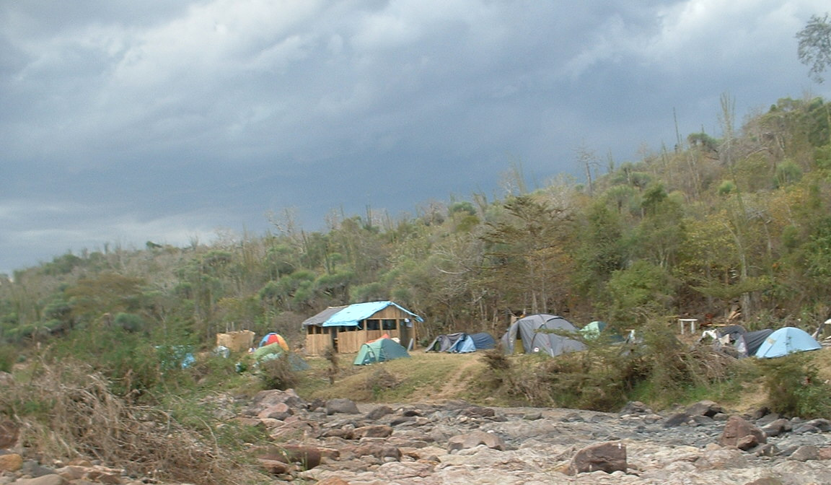
Having organised travel and transfers, with the support of the Rennie bequest, travel to the operation site took a few days, starting from Paris flying to Tana, the capital city, and there met some other research assistants. We were able to look round the city and the difference in living conditions, and approach to life was fascinating, and thought provoking, we were certainly a novelty for the locals. We then flew to the south of the island to Fort Dauphin, where we were met by the project leader for the transfer to the camp itself. It was a five hour drive to Ifotaka, in minibuses that had certainly seen better days. Despite the uncomfortable seats the countryside we passed though was incredible, and very different to anything I had experienced before. We drove through the mountains and through several different regions and I got a small sense of the size of the country I was in, and how varied the ecosystems were within a relatively small area. Arriving at Ifotaka we then walked to the camp itself, by this time it was dark and it wasn't until the morning that we were able to appreciate the camp. We camped in tents, and there were 'long drop' toilets, and bucket showers, there was one building, made last year as a work area, and a small shop selling chocolate and various souvenirs, with the proceeds going towards the local community. There a were a number of locals working as guides, cooks and guards, and we got to know them well during the month.

The first 5 days were taken up with lectures into the conservation area and its history as well lectures on the biodiversity and the local community. The organisation of the projects was such that the research assistants were divided into a number of small groups and each group was rotated around the different research teams. We spent 6 days on the herpetology team, 6 days with the lemur team, and 3 days on the bird team and 3 days with the vegetation team. For each team we had to learn various sampling and data collection techniques.

The nature of the research and data collections the overall conclusions and findings are part of long term projects, so the final findings and analysis of the data are still being worked on.

The herpetology data focuses on assessment of the relative abundance of species, and the difference between disturbed and undisturbed areas. We were given an identification course and taught to identify species down to order level. Certain species such would require detailed data collection such as scale counts and size. Data collection was by day and night transects, opportunistic searches within a 50m2 grid. In addition data collected from Foam was used as the tree cover objects on the trunks, with aluminium sheet cover as ground cover objects, 5 pairs set out along a 50m transect. Aluminium was only material available, due to limitations of where were were and attainability of any resources, and this did not heat up well. The use of the ground and tree cover objects had also been indented as a trail of the effectiveness of the method, which led to a conclusion that this method, unless refined was not very effective.

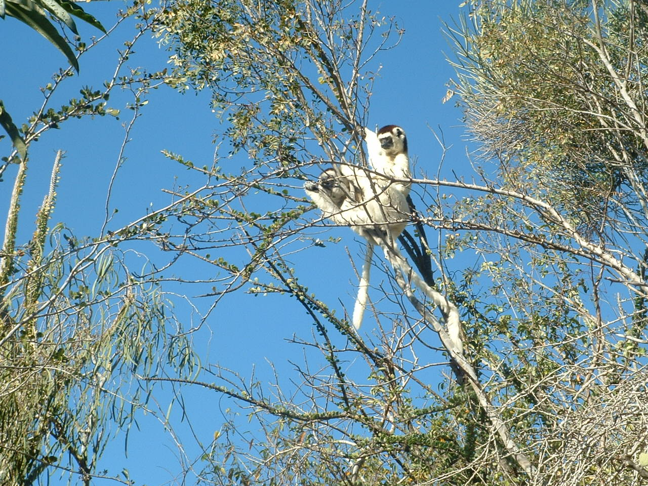
Pitfall traps were also used to measure diversity and abundance, dug in randomly allocated locations within disturbed and undisturbed areas, although limitations such as the quality of the grounds restricted the locations. GPS measurements of trap location taken and mapped to Google Earth map grid. It was hard work to dig the traps ourselves, especially in the hot sun, but very exciting to check the traps in the morning, as in we found all sort of creatures! There was also a behavioural study into the interactions between two species of iguanas, Oplurus saxicola and Oplurus quadrimaculatus. Behaviour of labelled individuals of these species were observed for 1/2 stretches and a behavioural ethogram filled out. Studies were carried out at three different sites were the species were known to co-exist.

Lemur research was focused on two habituated family groups of Verreaux's sifaka from both disturbed and undisturbed areas. For the behavioural studies one individual was followed for the whole day and any eating, defecation or urination observed, as well as the time spent. Instantaneous scans were also carried out as every five minutes the activities of all members of the groups were recorded. These studies gave us the chance to sit on the top of cliffs with an incredible view and be within 1m of several lemurs. It was hard to tell the individuals apart at the start but by three days it was easier, and a highlight was when a few days before we were due to leave, one of the females gave birth and we were able to see the baby. The habitat studies were carried out by Point Quarter transects. A centre tree, which would have been previously marked as a tree used by the lemur group in the area, this then involved measurements and identification of four trees NE, NW, SE, SW of the centre tree, as well as GPS of centre tree and calculating the disturbance factor. Studies will determine if the lemur dietary habit is affected by disturbance as well as the effect on home range Population density walks were also carried out to determine the number of groups in the area. Mouse lemur trapping was also carried out but the Sherman trapping was restricted rain meant we were unable to set the traps, and time was also often a limiting factor. Sportive lemur night walks were also carried out, the species is currently data deficient on the ICUN list.

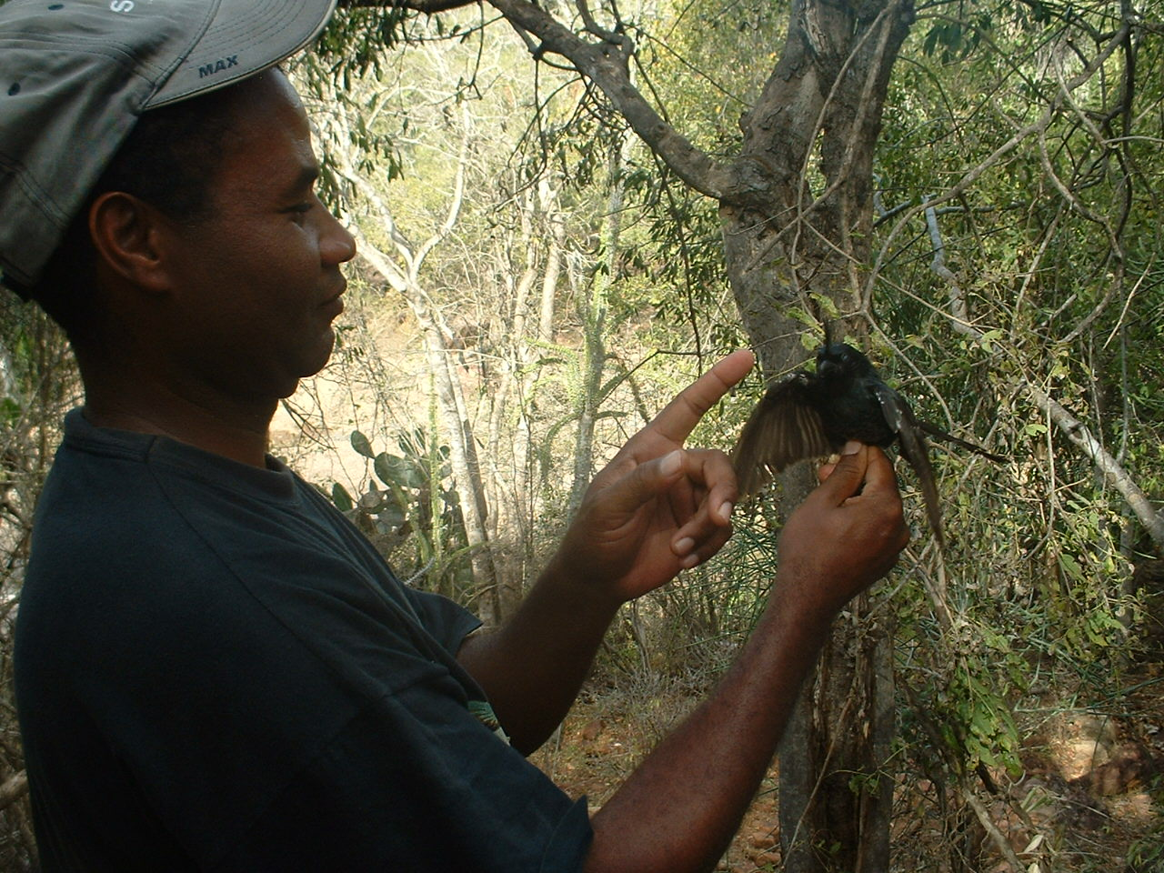
The bird research investigated was carried out by timed species counts of 1 hr walking 300m transect, identifying species heard and seen and their niche. From this species discovery curves, species richness and relative abundance could be calculated,. Mist netting was also carried out, and checked three times a day, and any individuals found measured and identified before being released. This data will help determine the affect of disturbance and undisturbed areas on bird communities, as well as the effect on communities in gallery forest and spiny forest. I found it constantly amazing how species, even those that I was familiar with such as crows and Kestrels, and Kingfishers were so different, it also became something of a challenge to be able to identify the birds by their calls as the team leader could. These walks also gave us the chance to see more of the area surrounding the camp, which I really enjoyed as it was fascinating to see such different vegetation and landscapes.

The vegetation was supplying data to support the other teams, and involved 100m transects, taking canopy cover measurements, highest and lowest points as well as identification and measurements of every tree within a 2m channel down the transect. The area itself suffers from several threats of deforestation for agricultural and commercial reasons. We also carried out invasive species transects, which involved 10 members spread out and a 100m straight line, any number of invasive species noted. This work was physically very hard work as the surveying involved walking through the spiny forest, which never failed to live up to its name. The vegetation was very dense and would constantly catch on skin and clothing, yet I really enjoyed the activity.

In addition to these days of research we were able to give back to the local community which had welcomed us so well by burning some of the invasive Raketa plant, which is inedible for the local cattle, as well as visiting a local village and transporting sand, cement and water to help cement a school floor. Both these days were hard work, especially carrying sand and water from the river up to the village, and we were recruited to pull the cart that was used to carry up the bags of cement and water, but very enjoyable to do something different in the local area.

I would like to acknowledge and thank the James Rennie Bequest for making this experience with Opwall in Madagascar possible, the grant enabled me to meet the internal flights costs as well as preparing for the tip. I had an incredible time on this expedition and gained a lot from being able to be involved with the different types field research, and I learnt a lot of practical research skills. I had been taught the basic but it was very useful to learn the whole process, for instance with pitfall traps, trying to balance random lines with feasibility, then making the traps and then returning to check them. The identification skills were also very useful, although very specific to the species we ere looking for, I got a much better idea of how to start learning indemnification, and the methods of identification will be transferable. I have also enjoyed working within a team, but this was new as I did not know anyone in my group, and we were a range of ages and so this trip did greatly improve my team skills. The camp conditions were challenging at first, with sleeping on uncomfortable ground for the month with long drop toilets and bucket showers, and limited food variety, I became used to it faster that I thought, and did enjoy the whole experience. The work has given me a new enthusiasm to conservation work, and provided a different approach to the academic study of ecology and conservation. I hope to become more practically involved back in the U.K, and the introduction to development and practical side of research has helped me consider my own research and career options within biology. I have always loved being active and exploring the countryside at home, and this trip gave me an opportunity to experience entirely new surroundings, culture and biodiversity, which I found fascinating. I am very grateful for the funding which gave me such an invaluable and unforgettable trip.

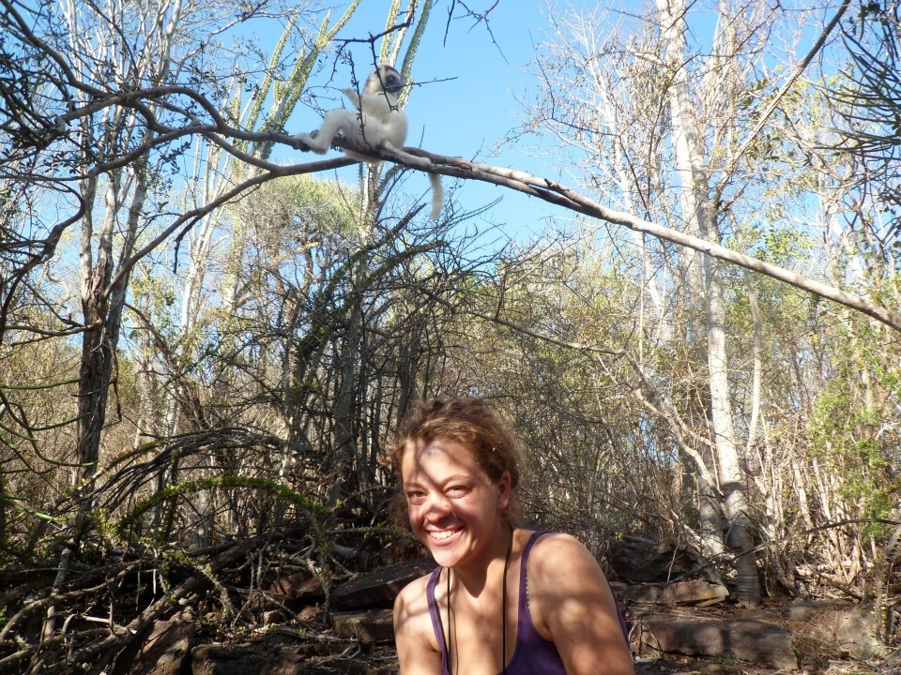
Sarah Aldous

